**Sign Tone: A Deep Learning-Based Deaf Companion System for Two-Way Communication between Deaf and Non-Deaf Individuals**

**Abstract**

Communication is essential to express and receive information, knowledge, ideas, and views among people, but it has been quite a while to be an obstruction for people with hearing and mute disabilities. Sign language is one method of communicating with deaf people. Though there is sign language to communicate with non-sign people it is difficult for everyone to interpret and understand. The performance of existing sign language recognition approaches is typically limited. Developing an assistive device that will translate the sign language to a readable format will help the deaf-mutes to communicate with ease to the common people. Recent advancements in the development of deep learning, deep neural networks, especially Temporal convolutional networks (TCNs) have provided solutions to the communication of deaf and mute individuals. In this project, the main objective is to design Deaf Companion System for that to develop SignNet Model to provide two-way communication of deaf individuals and to implement an automatic speaking system for deaf and mute people. It provides two-way communication for all classes of people (deaf-and-mute, hard of hearing, visually impaired, and non-signers) and can be scaled commercially. The proposed system, consists of three modules; the sign recognition module (SRM) that recognizes the signs of a deaf individual using TCN, the speech recognition using Hidden Marko Model and synthesis module (SRSM) that processes the speech of a non-deaf individual and converts it to text, and an Avatar module (AM) to generate and perform the corresponding sign of the non-deaf speech, which were integrated into the sign translation companion system called deaf companion system to facilitate the communication from the deaf to the hearing and vice versa. The proposed model is trained on Indian Sign Language. Then developed a web-based user interface to deploy SignNet Model for ease of use. Experimental results on MNIST sign language recognition datasets validate the superiority of the proposed framework. The TCN model gives an accuracy of 98.5%.

**TABLE OF CONTENTS**

|  |  |  |
| --- | --- | --- |
| **C. NO** | **TITLE** | **PAGE NO** |
|  | **ABSTRACT** | **I** |
| **1** | **INTRODUCTION** |  |
|  | 1.1. Company Profile |  |
|  | 1.2. Project Profile |  |
| **2** | **SYSTEM ANALYSIS** |  |
|  | 2.1. Existing System |  |
|  | 2.2. Proposed System |  |
| **3** | **SYSTEM REQUIREMENTS** |  |
|  | 3.1. Hardware Requirements |  |
|  | 3.2. Software Requirements |  |
|  | 3.3. Software Description |  |
| **4** | **SYSTEM DESIGN** |  |
|  | 4.1. System Architecture |  |
|  | 4.2. Data Flow Diagram |  |
|  | 4.3. Database Design |  |
|  | 4.4. UML Diagram |  |
|  | 4.5. ER Diagram |  |
| **5** | **SYSTEM TESTING** |  |
|  | 5.1. Software Testing |  |
|  | 5.2. Test Cases |  |
|  | 5.3. Test Report |  |
| **6** | **SYSTEM IMPLEMENTATION** |  |
|  | 6.1. System Description |  |
|  | 6.2. System Flow |  |
|  | 6.3. Modules Description |  |
| **7** | **APPENDICES** |  |
|  | 7.1. Source Code |  |
|  | 7.2. Screenshots |  |
| **8** | **CONCLUSION** |  |
|  | 8.1. Conclusion |  |
|  | 8.2. Future Enhancement |  |
| **9** | **BIBLIOGRAPHY** |  |
|  | 9.1. Journal Reference |  |
|  | 9.2. Book Reference |  |
|  | 9.3. Web References |  |

**1.INTRODUCTION**

**1.1. COMPANY PROFILE**

The Mind IT Solution is one of the few IT system integration, professional service and software development companies in Macedonia that works with Enterprise systems and companies which has sister concern in Trichy. As a privately owned company, The Mind IT Solution provides IT Consultancy, software design and development as well as professional services and hardware deployment and maintenance to the following verticals: Government (Local and Central), Financial Services (insurance, banking and clearing house), Telecommunications, Energy and Utilities, Health Care and Education.

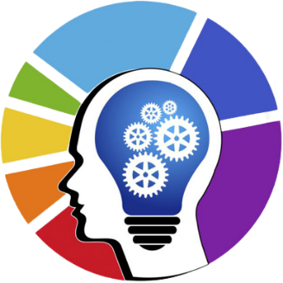

**Mission**

The Mind IT Solution’ mission is to enhance the business operation of its clients by developing and/or implementing premium IT products and services.

* Providing high quality software development services, professional consulting and development outsourcing that would improve our customers’ operations
* Making access to information easier and securer (Enterprise Business)
* Improving communication and data exchange (Business to Business)
* Providing our customers with a Value for Money and

**Vision**

The Mind IT Solution is a leading IT company for Consulting Services and Deployment of best of breed Business Solutions to top tier domestic and international customers.

**Contact us**

**The Mind IT**

No.1, Ground Floor, Christ Church Complex,

Chatram bus stand, Trichy, Tamil Nadu-620002.

www.themind.co.in, [hr@themind.co.in](mailto:hr@themind.co.in),

0431-3562302.

**1.2. PROJECT PROFILE**

**1.2.1 OVERVIEW**

Sign language is manual communication commonly used by people who are deaf. Sign language is not universal; people who are deaf from different countries speak different sign languages. The gestures or symbols in sign language are organized in a linguistic way. Each individual gesture is called a sign. Each sign has three distinct parts: the handshape, the position of the hands, and the movement of the hands. American Sign Language (ASL) is the most commonly used sign language in the India.

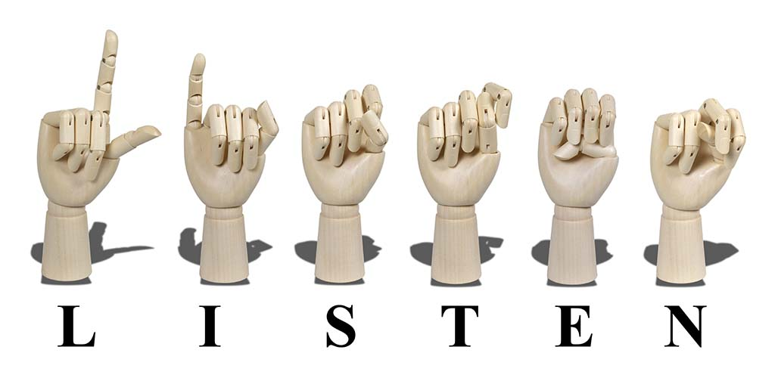

Figure 1.1. Sign Language

A sign language (also signed language) is a language which uses manual communication, body language, and lip patterns instead of sound to convey meaning—simultaneously combining hand shapes, orientation and movement of the hands, arms or body, and facial expressions to fluidly express a speaker's thoughts. Signs often represent complete ideas, not only words. However, in addition to accepted gestures, mime, and hand signs, sign language often includes finger spelling, which involves the use of hand positions to represent the letters of the alphabet.

Sign languages have developed in circumstances where groups of people with mutually unintelligible spoken languages found a common base and were able to develop signed forms of communication. Sign languages commonly develop in deaf communities, which include people who are deaf or hard of hearing, friends and families of deaf people, as well as interpreters.

**1.2.2 PROBLEM STATEMENT**

Sign language recognition is a typical application of hand gesture recognition. It is often considered that only deaf people rely on sign languages for conveying their thoughts. However, particular medical problems such as down syndrome, autism, cerebral palsy, trauma, and brain diseases or speech difficulties may require a nonverbal mode of communication. 6,909 spoken languages and 138 sign languages have been identified, but there is no universal sign language. Each has its own syntactical and grammatical structures to provide definitive means of communication, primarily for deaf communities worldwide. Sign languages emphasize on the movement of the hands, arms, head, and body in a conceptually predetermined manner to significantly construct a gesture language. Indian Sign Language (ISL) is the name given to the sign language used in India. According to the 2011 census, 2.7 million people in India cannot speak, and 1.8 million are deaf. They face difficulty communicating with others because most normal people are unfamiliar with sign language. However, communication between them becomes inevitable in emergencies. Sign language interpreters are required to convert sign language to spoken language and vice versa, but their supply is limited and expensive. As a result, automatic sign language recognition systems are needed to translate signs into corresponding text or voice without the assistance of interpreters. Through human-computer interaction, systems can be built to aid in the development of the deaf and other communities who rely on sign languages. In recent years, there have been ongoing efforts to develop automated methods for the completion of numerous linguistic tasks using advanced algorithms that can ‘learn’ based on past experience. Sign language recognition (SLR) is an area where automation can provide tangible benefits and improve the quality of life for a significant number of people who rely on sign language to communicate on a daily basis. The successful introduction of such capabilities would allow for the creation of a wide array of specialized services, but it is paramount that automated SLR tools are sufficiently accurate to avoid creating confusing or dysfunctional responses. Recently, basic machine learning approaches have been largely replaced with deeper architectures that employ several layers and pass information in vector format between layers, gradually refining the estimation until positive recognition is achieved. Such algorithms are usually described as ‘‘deep learning’’ systems or deep neural networks, and they operate on principles similar to the machine learning strategies described above, although with far greater complexity.

**1.2.3. DEEP LEARNING**

Deep learning is a method in artificial intelligence (AI) that teaches computers to process data in a way that is inspired by the human brain. Deep learning models can recognize complex patterns in pictures, text, sounds, and other data to produce accurate insights and predictions.

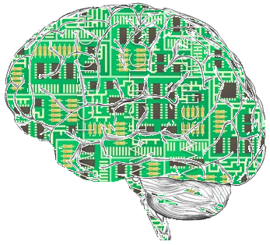

Figure 2: Deep Neuron

Deep learning algorithms are neural networks that are modeled after the human brain. For example, a human brain contains millions of interconnected neurons that work together to learn and process information. Similarly, deep learning neural networks, or artificial neural networks, are made of many layers of artificial neurons that work together inside the computer. Artificial neurons are software modules called nodes, which use mathematical calculations to process data. Artificial neural networks are deep learning algorithms that use these nodes to solve complex problems.

**1.2.3.1. Convolutional Neural Network**

In deep learning, a convolutional neural network (CNN) is a special type of neural network that is designed to process data through multiple layers of arrays. A CNN is well-suited for applications like image recognition and is often used in face recognition software. In CNN, convolutional layers are the fundamental building blocks that make all the magic happen. In a typical image recognition application, a convolutional layer is made up of several filters to detect the various features of the image. In a CNN for facial recognition, the network is trained on a dataset of face and non-face images. The CNN learns to identify important features of a face, such as the shape of the eyes, nose and mouth, as well as the general geometry and texture of the face. These features are then used to identify a face in a new image. The [architecture of a CNN](https://datascientest.com/en/convolutional-neural-network-everything-you-need-to-know) generally consists of several layers, each with a specific function. The first layer, called the input layer, receives the raw image data. Subsequent layers, called convolutional or hidden layers, use a set of filters to extract features from the image. These filters glide over the image (convolution stage), looking for specific patterns and features.

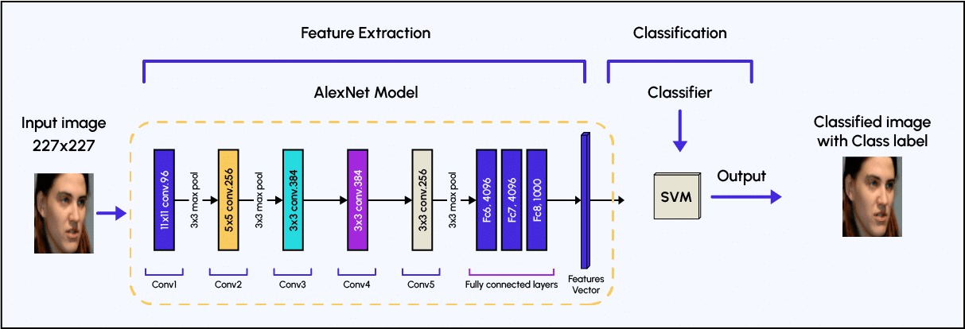

The resulting features are then passed through a non-linear activation function, **such as a rectified linear unit (ReLU),** which introduces non-linearity into the network and enables it to learn more complex patterns. After the convolutional layers, the network includes pooling layers, which reduce the spatial resolution of the features learned by the network while retaining important information. This is done by taking the maximum or average of a small region of the feature map. Pooling layers make the network more robust to small changes in the position of the face in the image. Finally, the features are passed through fully connected layers, which perform the classification task. These layers produce a probability for each possible class – in the case of facial recognition, a face or no face. This output is then compared with a threshold, to make the final decision. This threshold is used to decide how precise the decision should be. For example, if the threshold is 0.9, the model performs the face recognition task only when its performance in associating the image with a particular person is above this value.

**1.2.3.2. Temporal Convolutional Networks, The Next Revolution for Time-Series**

The seminal work of Lea et al. (2016) first proposed a Temporal Convolutional Networks (TCNs) for video-based action segmentation. The two steps of this conventional process include: firstly, computing of low-level features using (usually) CNN that encode spatial-temporal information and secondly, input these low-level features into a classifier that captures high-level temporal information using (usually) RNN. The main disadvantage of such an approach is that it requires two separate models. TCN provides a unified approach to capture all two levels of information hierarchically.

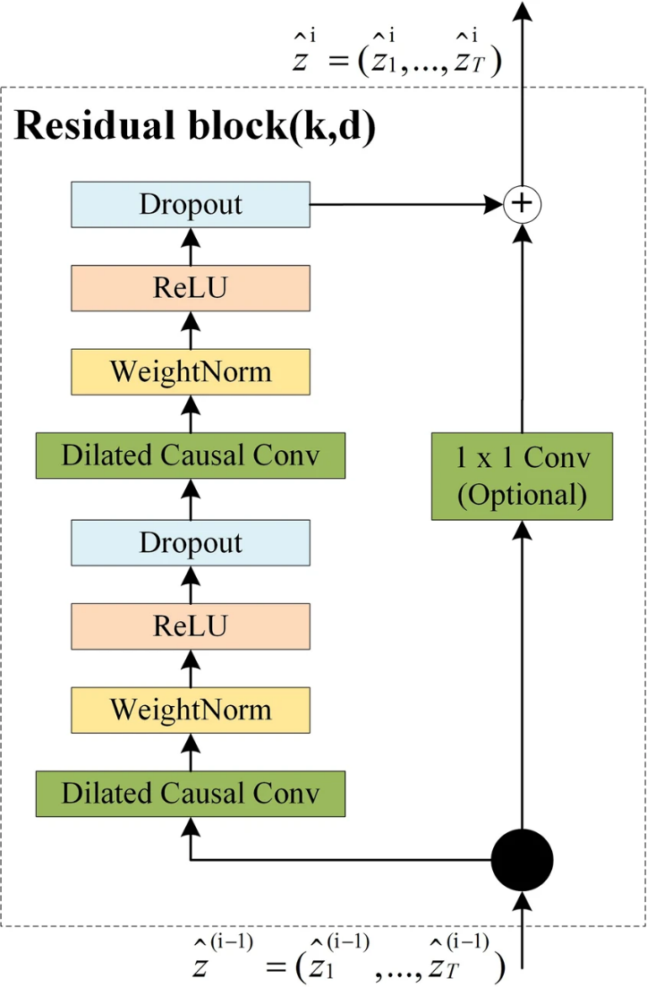

TCN model has two layers, i.e., a dilated causal convolution and non-linearity (ReLU), as well as weight normalization in between. In addition, a spatial dropout was added after each dilated convolution for regularization, and an additional 1×1 convolution was adopted to ensure that the element-wise addition ⊕ received tensors of the same shape to resolve the difference in input and output widths.

The typical characteristics of TCN includes: (1) It can take a sequence of any length and output it as a sequence of the same length with the input, just like using an RNN; and (2) the convolution is a causal convolution, which means that there is no information “leakage” from future to past. To reach the first goal, the TCN uses a one-dimensional, fully convolutional network (1D FCN) architecture46. That is, each hidden layer will be padded zero to maintain the same length with the input layer. To achieve the second point, the causal convolution, where an output at time *t* is convolved only with elements from time *t* and earlier in the previous layer, is adopted. In short, TCN is the sum of 1D FCN and causal convolutions.

**1.2.3.3. Benefits of TCN**

TCN model is deliberately kept simple, combining some of the best practices of modern convolutional architectures. Therefore, it can serve as a convenient but powerful starting point when dealing with sequential data. TCNs can be built to have very long effective history sizes, which means they have the ability to look very far into the past to make a prediction. To this end, a combination of very deep networks augmented with residual layers and dilated convolutions are deployed. The TCN architecture appears not only to be more accurate than canonical recurrent networks such as LSTMs and GRUs, it also contains the following properties:

**Parallelism:** Unlike in RNNs where the predictions for later time steps must wait for their predecessors to complete, convolutions can be calculated in parallel because the same filter is used in each layer. Therefore, in both training and evaluation, a long input sequence can be processed as a whole, instead of sequentially as in RNNs.

**Flexible receptive field size:** The receptive field size can be changed in multiple ways. For instance, stacking more dilated convolutional layers, using larger dilation factors, or increasing the filter size are all viable options. Thus, TCNs afford better control of the model’s memory size, and are easy to adapt to different domains.

**Low memory requirement for training:** Especially in the case of a long input sequence, LSTMs and GRUs can easily use up a lot of memory to store the partial results for their multiple cell gates. In TCNs, however, the filters are shared across a layer, with the back-propagation path depending only on the network depth.

**1.2.4. AIM AND OBJECTIVE**

The aim of this project is to develop a Deaf Companion System that utilizes advanced technologies, particularly Temporal Convolutional Networks (TCNs), to enhance communication between individuals with hearing and mute disabilities and the broader community. The system aims to overcome existing communication barriers by recognizing sign language gestures, converting non-deaf speech to text, and generating corresponding sign language avatars for seamless and inclusive two-way communication.

**Objective**

* To design and implement a robust SignNet Model using Temporal Convolutional Networks (TCNs) for accurate recognition of sign language gestures.
* To train the SignNet Model on a representative dataset, focusing on the cultural nuances of the Indian Sign Language.
* To implement a Hidden Markov Model (HMM)-based speech recognition system for converting spoken language from non-deaf individuals into text.
* To develop a synthesis module that generates corresponding sign language gestures based on the converted text.
* To create an Avatar Module capable of generating realistic and culturally sensitive sign language avatars aligned with converted text.
* To seamlessly integrate the Sign Language Recognition, Speech Recognition and Synthesis, and Avatar Modules into a unified Deaf Companion System.
* To design and implement an accessible and user-friendly web-based interface for deploying the SignNet Model and the Deaf Companion System.
* To explore opportunities for commercial scalability through partnerships and collaborations, ensuring adaptability for diverse environments and user groups.
* To conduct comprehensive testing and validation of the system's accuracy, reliability, and real-world applicability.
* To prioritize cultural sensitivity and inclusivity, addressing variations in sign languages and considering the needs of diverse user groups.

**1.2.5. SCOPE OF THE PROJECT**

The scope of the project encompasses the following key areas:

* **Sign Language Recognition Module (SRM)**

Designing and implementing a robust SignNet Model based on Temporal Convolutional Networks (TCNs) for accurate recognition and interpretation of sign language gestures. Training the SignNet Model on a representative dataset, with a focus on the cultural nuances of the Indian Sign Language.

* **Speech Recognition and Synthesis Module (SRSM)**

Implementing a Hidden Markov Model (HMM)-based speech recognition system to convert spoken language from non-deaf individuals into text. Developing a synthesis module to process the text and generate corresponding sign language gestures.

* **Avatar Module (AM)**

Creating an Avatar Module capable of generating realistic and culturally sensitive sign language avatars aligned with the converted text from non-deaf speech.

* **Integration into Deaf Companion System**

Integrating the Sign Language Recognition Module, Speech Recognition and Synthesis Module, and Avatar Module into a unified Deaf Companion System. Ensuring seamless operation to facilitate effective communication between deaf individuals and non-deaf individuals, accommodating varying communication needs.

* **Web-Based User Interface**

Designing and implementing an accessible and user-friendly web-based interface to deploy the SignNet Model and the entire Deaf Companion System. Prioritizing an intuitive interface that caters to the diverse needs of both deaf and non-deaf users.

* **Commercial Scalability**

Investigating opportunities for commercial scalability, exploring potential partnerships and collaborations to make the Deaf Companion System widely accessible. Considering adaptability for diverse environments and user groups to ensure scalability.

Top of Form

**2.SYSTEM ANALYSIS**

**2.1. EXISTING SYSTEM**

The traditional systems for communication and education for the deaf community have often relied on established methods, but these methods may have limitations in addressing the diverse needs of individuals with hearing and mute disabilities. Some aspects of the traditional system include:

* **Sign Language**

Manual Communication: Sign language, such as American Sign Language (ASL) or other regional sign languages, has been a primary mode of communication for the deaf community.

* **Educational Approaches**

Specialized Schools: Deaf individuals often attend specialized schools where sign language is a primary mode of instruction.

* **Assistive Devices**

Hearing Aids and Cochlear Implants: Traditional assistive devices include hearing aids and cochlear implants, which aim to improve auditory perception.

* **Manual Communication Tools:**

Pen and Paper: Traditional tools such as writing or using pen and paper are often employed for basic communication.

* **Interpreters:**

Sign Language Interpreters: In various situations, sign language interpreters are employed to bridge communication gaps between deaf and hearing individuals.

* **Printed Materials:**

Books and Written Resources: Printed materials, including books and written resources, have been essential for education.

**EXISTING ALGORITHMS**

Sign language recognition (SLR) is a challenging task due to the complexity and variability of sign language gestures. Several algorithms and approaches have been developed to address this task, with varying levels of success. One prominent existing algorithm for SLR is the Hidden Markov Model (HMM) based approach.

* **Support Vector Machines (SVM)**

SVMs are used to classify sign language gestures based on extracted features. They work well with high-dimensional feature spaces.

* **Ensemble Learning**

Ensemble methods, such as Random Forests and Gradient Boosting, can be applied to combine multiple SLR models to improve overall accuracy and robustness.

* **Gesture Recognition by Learning from Poses (GRBP)**

GRBP is a method that focuses on learning spatial relations between body joint poses for sign language recognition. It utilizes pose features extracted from skeletal data.

**2.1.1. DISADVANTAGE**

* Traditional systems lead to limited accessibility, hindering communication with non-signers.
* Real-time processing challenges persist, especially for resource-constrained devices.
* Handling natural variability in sign language gestures remains a challenge for rule-based models.
* Existing algorithms lack adaptability to diverse sign language variations.
* Difficult to interpret the decision-making process.
* Face challenges in adapting to unseen variations or emerging sign language expressions.
* Challenges in modeling the context and semantic relationships between signs.

**2.2. PROPOSED SYSTEM**

The proposed system for the project, titled "Deaf Companion System," is designed to revolutionize communication for individuals with hearing and mute disabilities. Key components and features of the system include:

* **Deaf Companion System**

Introduction of an innovative system addressing communication challenges faced by individuals with hearing and mute disabilities.

* **SignNet Model Architecture**

Development of the SignNet Model, combining Convolutional Neural Networks (CNN) and Temporal Convolutional Networks (TCN) for robust sign language recognition.

* **Two-Way Communication**

Implementation of a comprehensive two-way communication system, fostering seamless interaction between deaf individuals and the broader community.

* **Sign Language Recognition Module (SRM)**

Integration of the SRM, utilizing the SignNet Model to accurately interpret sign language gestures in real-time, ensuring contextual understanding.

* **Speech Recognition and Synthesis Module (SRSM)**

Incorporation of an SRSM employing Hidden Markov Models to convert non-deaf speech into text, facilitating comprehensive communication.

* **Avatar Module (AM)**

Creation of an AM to generate realistic sign language avatars synchronized with non-deaf speech, enhancing visual communication.

* **Cultural Sensitivity and Inclusivity**

Emphasis on cultural sensitivity by training the system on the Indian Sign Language, ensuring inclusivity for diverse communication needs.

* **Web-Based User Interface**

Development of a user-friendly web interface for easy deployment of the SignNet Model, promoting accessibility for both deaf and non-deaf users.

**2.2.1. ADVANTAGE**

* Integration of CNN and TCN ensures precise sign language gesture recognition with superior accuracy.
* TCN implementation enables real-time recognition, fostering dynamic communication interactions for deaf individuals and non-signers.
* Comprehensive system design incorporates both sign language recognition and speech-to-text conversion, enabling seamless communication between deaf and non-deaf individuals.
* Avatar Module generates realistic sign language avatars synchronized with non-deaf speech, enhancing visual communication effectiveness.
* System trained on Indian Sign Language showcases cultural sensitivity, addressing specific needs and nuances of the target user group.
* Web-based interface ensures ease of deployment for the SignNet Model, providing a user-friendly experience for diverse users.
* Caters to deaf-and-mute, hard of hearing, visually impaired, and non-signing individuals, fostering inclusivity in communication.
* Designed with commercial scalability in mind, making it adaptable for widespread use in various environments and contexts.
* Framework validated on MNIST sign language recognition datasets, establishing its superior accuracy and real-world applicability.
* The proposed system revolutionizes communication for individuals with hearing and mute disabilities by overcoming barriers and enhancing accessibility.

**3.SYSTEM REQUIREMENTS**

**3.1. HARDWARE REQUIREMENTS**

* **Processor** : Intel Core i5 or equivalent
* **RAM**  : 8GB or higher
* **Storage**  : Minimum 256GB SSD or HDD
* **Webcam** : Built-in or external webcam for video input
* **Microphone** : Built-in or external microphone for audio input
* **Display** : Minimum 13-inch display with a resolution of 1920x1080 pixels
* **Internet Connection** : Broadband connection for online functionality

**3.2. SOFTWARE REQUIREMENTS**

* **Operating System:** Windows 10,
* **Web Browser:** Google Chrome, Mozilla Firefox, or Safari
* **Python**: Version 3.9 or higher
* **Flask**: Web application framework for backend development
* **MySQL**: Relational database management system for data storage
* **TensorFlow**: Deep learning framework for machine learning tasks
* **Pandas, NumPy, and Scikit-learn**: Python libraries for data manipulation and machine learning
* **Matplotlib and Seaborn**: Python libraries for data visualization
* **OpenCV**: Library for image processing tasks
* **Bootstrap**: Frontend framework for responsive web design

These are the minimum hardware and software requirements to run the Deaf Companion System effectively.

**3.3. SOFTWARE DESCRIPTION**

**3.3.1. PYTHON 3.7.4**

Python is a general-purpose interpreted, interactive, object-oriented, and high-level programming language. It was created by Guido van Rossum during 1985- 1990. Like Perl, Python source code is also available under the GNU General Public License (GPL). This tutorial gives enough understanding on Python programming language.

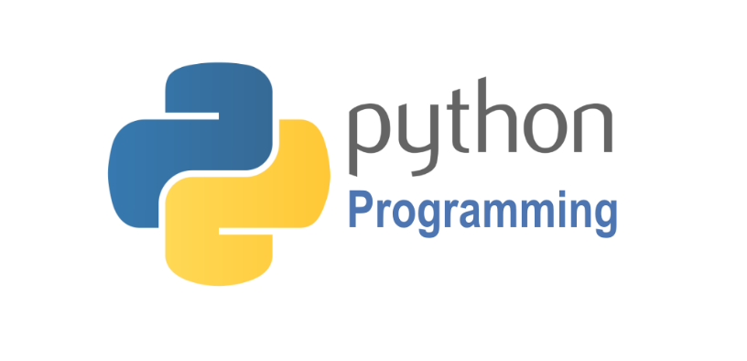

Python is a high-level, interpreted, interactive and object-oriented scripting language. Python is designed to be highly readable. It uses English keywords frequently where as other languages use punctuation, and it has fewer syntactical constructions than other languages. Python is a MUST for students and working professionals to become a great Software Engineer specially when they are working in Web Development Domain.

Python is currently the most widely used multi-purpose, high-level programming language. Python allows programming in Object-Oriented and Procedural paradigms. Python programs generally are smaller than other programming languages like Java. Programmers have to type relatively less and indentation requirement of the language, makes them readable all the time. Python language is being used by almost all tech-giant companies like – Google, Amazon, Facebook, Instagram, Dropbox, Uber… etc. The biggest strength of Python is huge collection of standard library which can be used for the following:

* Machine Learning
* GUI Applications (like Kivy, Tkinter, PyQt etc. )
* Web frameworks like Django (used by YouTube, Instagram, Dropbox)
* Image processing (like OpenCV, Pillow)
* Web scraping (like Scrapy, BeautifulSoup, Selenium)
* Test frameworks
* Multimedia
* Scientific computing
* Text processing and many more.

**Tensor Flow**

TensorFlow is an end-to-end open-source platform for machine learning. It has a comprehensive, flexible ecosystem of tools, libraries, and community resources that lets researchers push the state-of-the-art in ML, and gives developers the ability to easily build and deploy ML-powered applications.

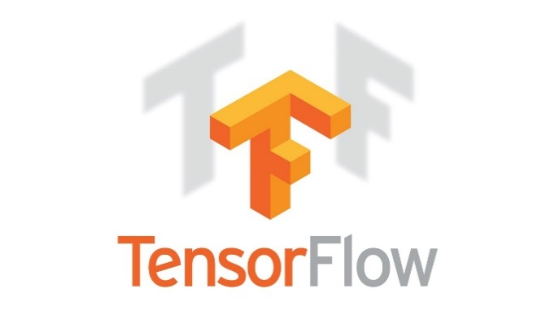

TensorFlow provides a collection of workflows with intuitive, high-level APIs for both beginners and experts to create machine learning models in numerous languages. Developers have the option to deploy models on a number of platforms such as on servers, in the cloud, on mobile and edge devices, in browsers, and on many other JavaScript platforms. This enables developers to go from model building and training to deployment much more easily.

**Keras**

Keras is a deep learning API written in Python, running on top of the machine learning platform TensorFlow. It was developed with a focus on enabling fast experimentation.

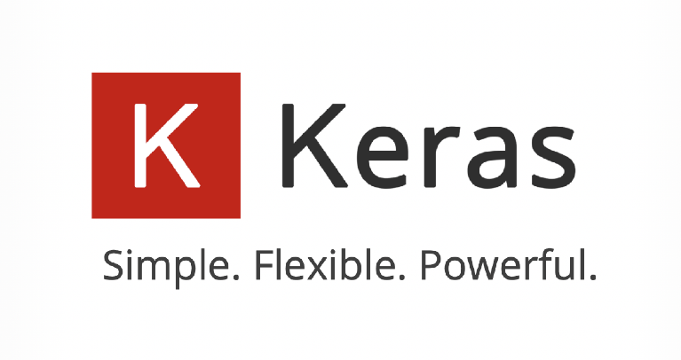

* Allows the same code to run on CPU or on GPU, seamlessly.
* User-friendly API which makes it easy to quickly prototype deep learning models.
* Built-in support for convolutional networks (for computer vision), recurrent networks (for sequence processing), and any combination of both.
* Supports arbitrary network architectures: multi-input or multi-output models, layer sharing, model sharing, etc. This means that Keras is appropriate for building essentially any deep learning model, from a memory network to a neural Turing machine.

**Pandas**

pandas is a fast, powerful, flexible and easy to use open source data analysis and manipulation tool, built on top of the Python programming language. pandas is a Python package that provides fast, flexible, and expressive data structures designed to make working with "relational" or "labeled" data both easy and intuitive. It aims to be the fundamental high-level building block for doing practical, real world data analysis in Python.



Pandas is mainly used for data analysis and associated manipulation of tabular data in Data frames. Pandas allows importing data from various file formats such as comma-separated values, JSON, Parquet, SQL database tables or queries, and Microsoft Excel. Pandas allows various data manipulation operations such as merging, reshaping, selecting, as well as data cleaning, and data wrangling features. The development of pandas introduced into Python many comparable features of working with Data frames that were established in the R programming language. The panda’s library is built upon another library NumPy, which is oriented to efficiently working with arrays instead of the features of working on Data frames.

**NumPy**

NumPy, which stands for Numerical Python, is a library consisting of multidimensional array objects and a collection of routines for processing those arrays. Using NumPy, mathematical and logical operations on arrays can be performed.

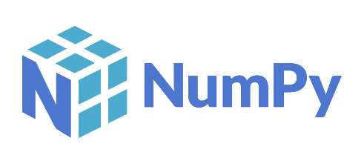

NumPy is a general-purpose array-processing package. It provides a high-performance multidimensional array object, and tools for working with these arrays.

**Matplotlib**

Matplotlib is a comprehensive library for creating static, animated, and interactive visualizations in Python. Matplotlib makes easy things easy and hard things possible.



Matplotlib is a plotting library for the Python programming language and its numerical mathematics extension NumPy. It provides an object-oriented API for embedding plots into applications using general-purpose GUI toolkits like Tkinter, wxPython, Qt, or GTK.

**Scikit Learn**

scikit-learn is a Python module for machine learning built on top of SciPy and is distributed under the 3-Clause BSD license.

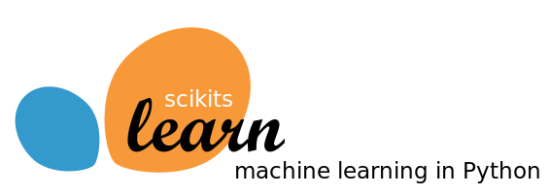

Scikit-learn (formerly scikits. learn and also known as sklearn) is a free software machine learning library for the Python programming language. It features various classification, regression and clustering algorithms including support-vector machines, random forests, gradient boosting, k-means and DBSCAN, and is designed to interoperate with the Python numerical and scientific libraries NumPy and SciPy.

**Pillow**

Pillow is the friendly PIL fork by Alex Clark and Contributors. PIL is the Python Imaging Library by Fredrik Lundh and Contributors.

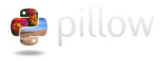

Python pillow library is used to image class within it to show the image. The image modules that belong to the pillow package have a few inbuilt functions such as load images or create new images, etc.

**OpenCV**

OpenCV is an open-source library for the computer vision. It provides the facility to the machine to recognize the faces or objects.

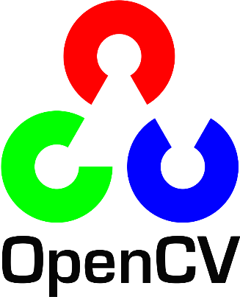

In OpenCV, the CV is an abbreviation form of a computer vision, which is defined as a field of study that helps computers to understand the content of the digital images such as photographs and videos.

**3.3.2 MYSQL**

MySQL is a relational database management system based on the Structured Query Language, which is the popular language for accessing and managing the records in the database. MySQL is open-source and free software under the GNU license. It is supported by Oracle Company. MySQL database that provides for how to manage database and to manipulate data with the help of various SQL queries. These queries are: insert records, update records, delete records, select records, create tables, drop tables, etc. There are also given MySQL interview questions to help you better understand the MySQL database.



MySQL is currently the most popular database management system software used for managing the relational database. It is open-source database software, which is supported by Oracle Company. It is fast, scalable, and easy to use database management system in comparison with Microsoft SQL Server and Oracle Database. It is commonly used in conjunction with PHP scripts for creating powerful and dynamic server-side or web-based enterprise applications. It is developed, marketed, and supported by MySQL AB, a Swedish company, and written in C programming language and C++ programming language. The official pronunciation of MySQL is not the My Sequel; it is My Ess Que Ell. However, you can pronounce it in your way. Many small and big companies use MySQL. MySQL supports many Operating Systems like Windows, Linux, MacOS, etc. with C, C++, and Java languages.

**3.3.3 WAMPSERVER**

WampServer is a Windows web development environment. It allows you to create web applications with Apache2, PHP and a MySQL database. Alongside, PhpMyAdmin allows you to manage easily your database.



WAMPServer is a reliable web development software program that lets you create web apps with MYSQL database and PHP Apache2. With an intuitive interface, the application features numerous functionalities and makes it the preferred choice of developers from around the world. The software is free to use and doesn’t require a payment or subscription.

**3.3.4. BOOTSTRAP 4**

Bootstrap is a free and open-source tool collection for creating responsive websites and web applications. It is the most popular HTML, CSS, and JavaScript framework for developing responsive, mobile-first websites.

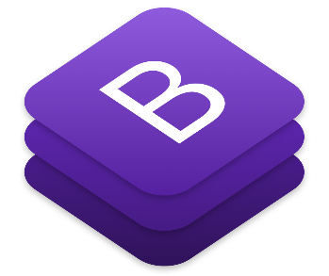

It solves many problems which we had once, one of which is the cross-browser compatibility issue. Nowadays, the websites are perfect for all the browsers (IE, Firefox, and Chrome) and for all sizes of screens (Desktop, Tablets, Phablets, and Phones). All thanks to Bootstrap developers -Mark Otto and Jacob Thornton of Twitter, though it was later declared to be an open-source project.

**Easy to use**: Anybody with just basic knowledge of HTML and CSS can start using Bootstrap

**Responsive features**: Bootstrap's responsive CSS adjusts to phones, tablets, and desktops

**Mobile-first approach**: In Bootstrap, mobile-first styles are part of the core framework

**Browser compatibility**: Bootstrap 4 is compatible with all modern browsers (Chrome, Firefox, Internet Explorer 10+, Edge, Safari, and Opera)

**3.3.5. FLASK**

[Flask](http://flask.pocoo.org/) is a web framework. This means flask provides you with tools, libraries and technologies that allow you to build a web application. This web application can be some web pages, a blog, a wiki or go as big as a web-based calendar application or a commercial website.

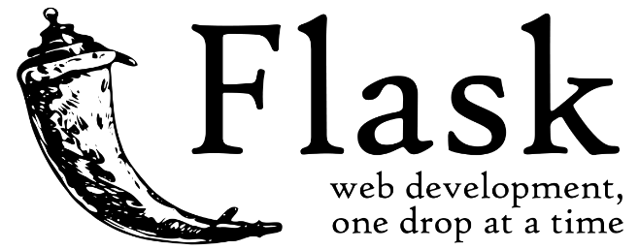

Flask is often referred to as a micro framework. It aims to keep the core of an application simple yet extensible. Flask does not have built-in abstraction layer for database handling, nor does it have formed a validation support. Instead, Flask supports the extensions to add such functionality to the application.  Although Flask is rather young compared to most [Python](https://quintagroup.com/services/python) frameworks, it holds a great promise and has already gained popularity among Python web developers. Let’s take a closer look into Flask, so-called “micro” framework for Python. Flask is part of the categories of the micro-framework. Micro-framework are normally framework with little to no dependencies to external libraries. This has pros and cons. Pros would be that the framework is light, there are little dependency to update and watch for security bugs, cons is that some time you will have to do more work by yourself or increase yourself the list of dependencies by adding plugins.

**4.SYSTEM DESIGN**

**4.1. SYSTEM ARCHITECTURE**

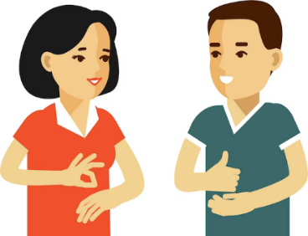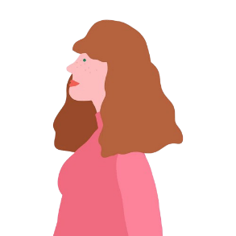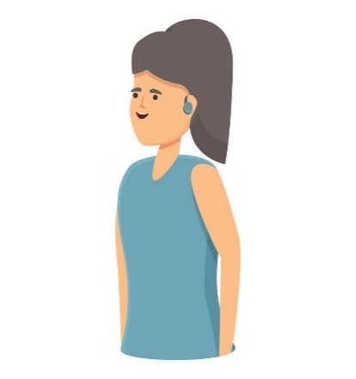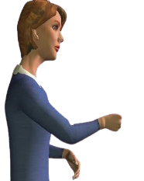

Login

SignNet Model: Train

System Maintenance

User Management

DCS Admin

Input Sign

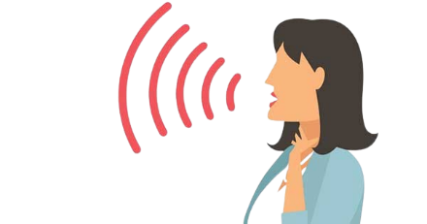

Input Sign

Output: Text & Voice

Output: Sign Avatar

Mute

Normal

Normal

Mute

Avatar

SL Recognition

ML Interpretation

SR & Speech Synthesis

Avatar Generation

**4.2. DATA FLOW DIAGRAM**

**LEVEL 0**

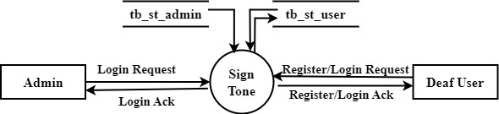

**LEVEL 1**

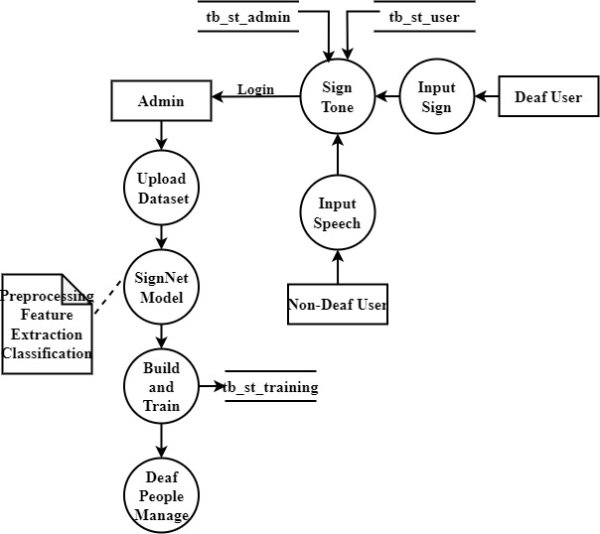

**LEVEL 2**

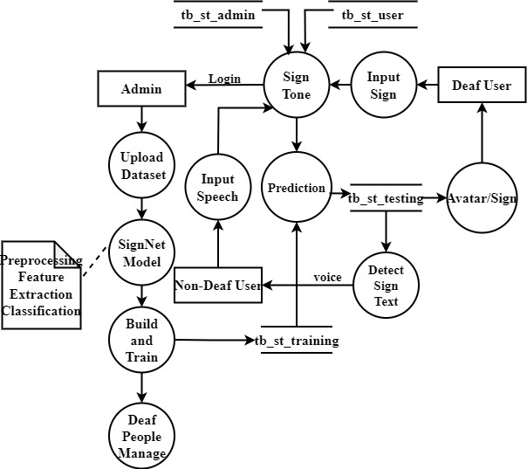

**4.3. DATABASE DIAGRAM**

| **ADMIN TABLE** | | | | | |
| --- | --- | --- | --- | --- | --- |
| **S.No** | **Field** | **Data Type** | **Field Size** | **Constraint** | **Description** |
| 1 | AdminID | int |  | Primary Key | Unique identifier for admin users |
| 2 | Username | varchar | 50 | Not Null | Username for admin login |
| 3 | Password | varchar | 50 | Not Null | Encrypted password for admin login |
| 4 | Email | varchar | 100 | Not Null | Email address of admin |
| 5 | Fullname | varchar | 100 | Not Null | Full name of admin |
| 6 | Timestamp | datetime |  | Not Null | Timestamp of admin creation |

| **USER TABLE** | | | | | |
| --- | --- | --- | --- | --- | --- |
| **S.No** | **Field** | **Data Type** | **Field Size** | **Constraint** | **Description** |
| 1 | UserID | int |  | Primary Key | Unique identifier for users |
| 2 | Username | varchar | 50 | Not Null | Username for user login |
| 3 | Password | varchar | 50 | Not Null | Encrypted password for user login |
| 4 | UserType | varchar | 20 | Not Null | Type of user (Deaf, Non-Deaf) |
| 5 | Email | varchar | 100 | Not Null | Email address of user |
| 6 | Fullname | varchar | 100 | Not Null | Full name of user |
| 7 | Timestamp | datetime |  | Not Null | Timestamp of user creation |

| **SIGNNET MODEL TRAINING TABLE** | | | | | |
| --- | --- | --- | --- | --- | --- |
| **S.No** | **Field** | **Data Type** | **Field Size** | **Constraint** | **Description** |
| 1 | GestureID | int |  | Primary Key | Unique identifier for gestures |
| 2 | GestureName | varchar | 50 | Not Null | Name of the sign language gesture |
| 3 | GestureImageURL | varchar | 255 | Not Null | URL of the image representing the gesture |
| 4 | Timestamp | datetime |  | Not Null | Timestamp of gesture creation |

| **SPEECH TO TEXT TABLE** | | | | | |
| --- | --- | --- | --- | --- | --- |
| **S.No** | **Field** | **Data Type** | **Field Size** | **Constraint** | **Description** |
| 1 | SpeechID | int |  | Primary Key | Unique identifier for speech entries |
| 2 | UserID | int |  | Foreign Key | Identifier of the user |
| 3 | SpeechText | varchar | 255 | Not Null | Text converted from speech |
| 4 | Timestamp | datetime |  | Not Null | Timestamp of speech conversion |

| **TEXT TO SIGN TABLE** | | | | | |
| --- | --- | --- | --- | --- | --- |
| **S.No** | **Field** | **Data Type** | **Field Size** | **Constraint** | **Description** |
| 1 | TextID | int |  | Primary Key | Unique identifier for text entries |
| 2 | UserID | int |  | Foreign Key | Identifier of the user |
| 3 | GestureID | int |  | Foreign Key | Identifier of the sign language gesture |
| 4 | Text | varchar | 255 | Not Null | Text input by the user |
| 5 | Timestamp | datetime |  | Not Null | Timestamp of text-to-sign language conversion |

| **AVATAR TABLE** | | | | | |
| --- | --- | --- | --- | --- | --- |
| **S.No** | **Field** | **Data Type** | **Field Size** | **Constraint** | **Description** |
| 1 | AvatarID | int |  | Primary Key | Unique identifier for avatars |
| 2 | UserID | int |  | Foreign Key | Identifier of the user |
| 3 | AvatarImageURL | varchar | 255 | Not Null | URL of the avatar image |
| 4 | Timestamp | datetime |  | Not Null | Timestamp of avatar creation |

| **SYSTEM LOG TABLE** | | | | | |
| --- | --- | --- | --- | --- | --- |
| **S.No** | **Field** | **Data Type** | **Field Size** | **Constraint** | **Description** |
| 1 | LogID | int |  | Primary Key | Unique identifier for log entries |
| 2 | UserID | int |  | Foreign Key | Identifier of the user generating logs |
| 3 | LogDescription | varchar | 255 | Not Null | Description of the system log event |
| 4 | Timestamp | datetime |  | Not Null | Timestamp of log entry |

**4.4. UML DIAGRAM**

**4.4.1. USE CASE DIAGRAM**

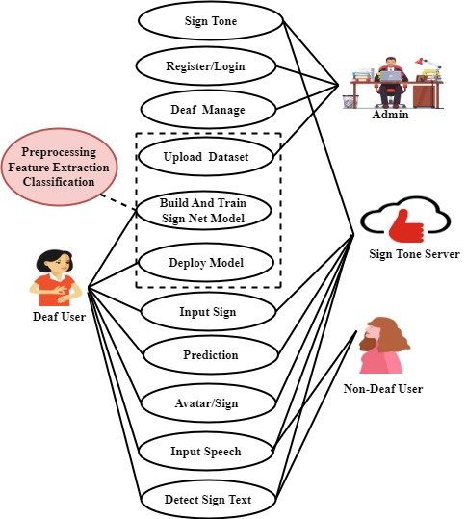

**4.4.2. CLASS DIAGRAM**

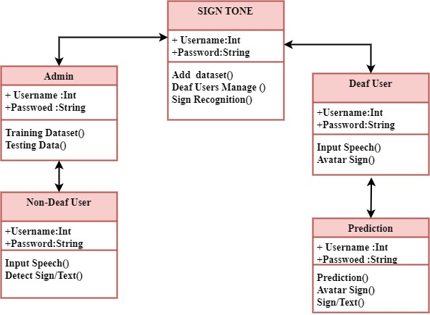

**4.4.3. SEQUENCE DIAGRAM**

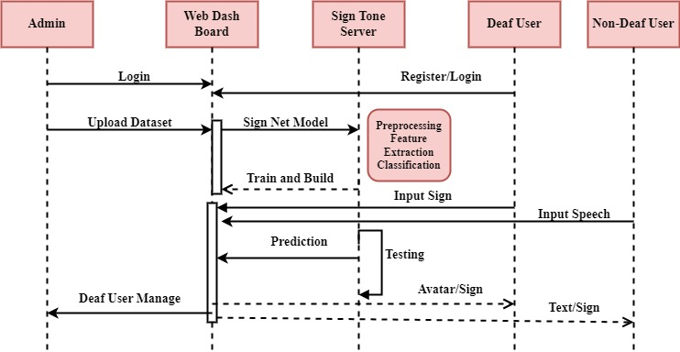

**4.4.4. ACTIVITY DIAGRAM**

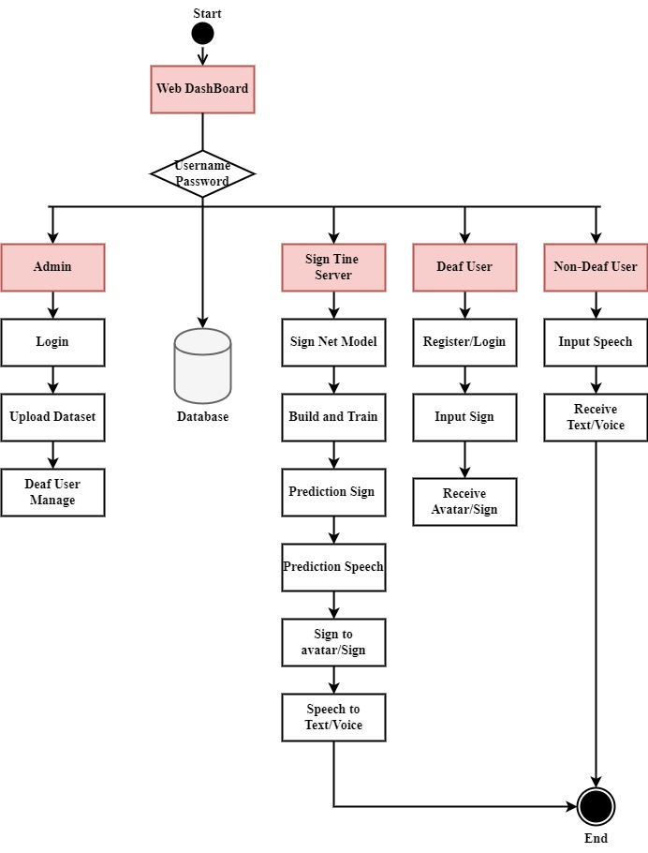

**4.4.5. COLLAPORATION DIAGRAM**

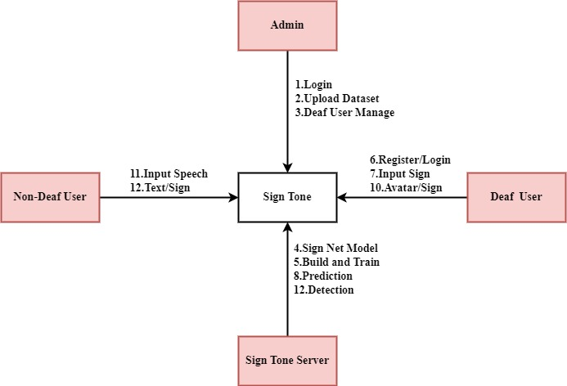

**4.4.6. DEPLOYMENT DIAGRAM**

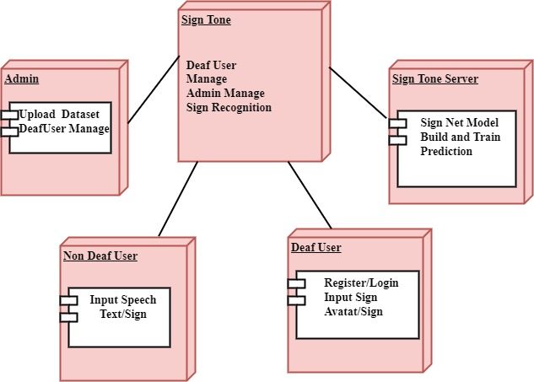

**4.5. ER - DIAGRAM**

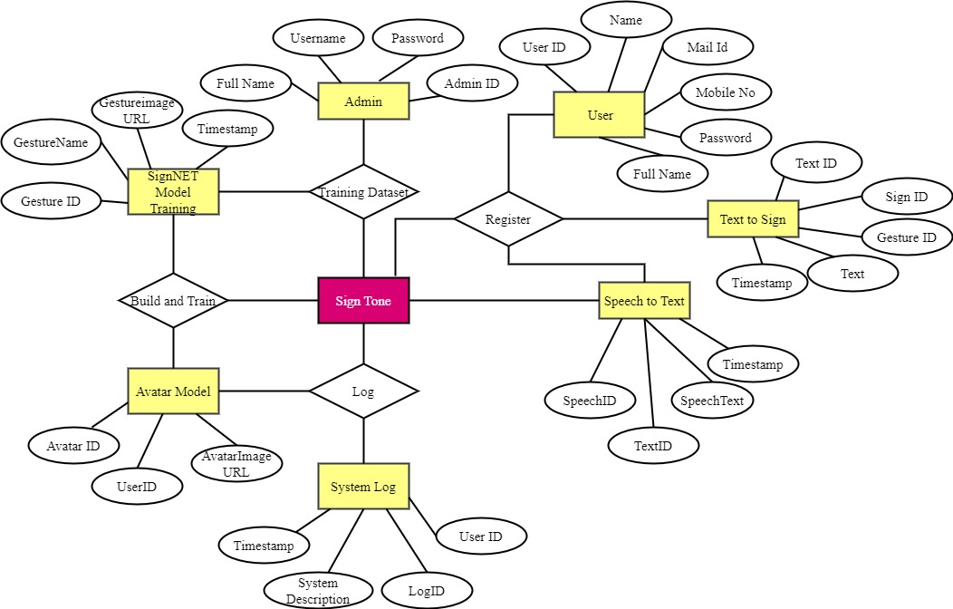

**5.SYSTEM TESTING**

**5.1. SOFTWARE TESTING**

System testing in the Deaf Companion System is essential to ensure its functionality, reliability, and usability. It involves evaluating the system's performance across various scenarios to identify and address any issues or deficiencies. Here's an overview of the different types of system testing that can be conducted:

1. Unit Testing:
   * Unit testing involves testing individual components or modules of the system in isolation to verify their correctness and functionality.
   * Each module, such as the Sign Language Recognition Module, Speech Recognition Module, and Avatar Generation Module, should undergo rigorous unit testing to ensure that it performs as expected.
   * Test cases are designed to cover all possible inputs, edge cases, and error conditions, ensuring comprehensive coverage of each module's functionality.
2. Integration Testing:
   * Integration testing focuses on testing the interactions and interfaces between different components or modules of the system.
   * In the Deaf Companion System, integration testing ensures that modules such as the Sign Language Recognition Module, Speech Recognition Module, and Avatar Generation Module work together seamlessly to facilitate communication between deaf and non-deaf users.
   * Test cases are designed to validate data flow, communication protocols, and error handling mechanisms between modules.
3. System Testing:
   * System testing evaluates the system as a whole to ensure that it meets its specified requirements and performs as intended in a real-world environment.
   * Test scenarios cover end-to-end user interactions, including sign language recognition, speech recognition, avatar generation, and communication between deaf and non-deaf users.
   * Functional testing, performance testing, and usability testing are conducted to assess the system's functionality, responsiveness, and user experience.
4. Acceptance Testing:
   * Acceptance testing involves validating the system against the user's acceptance criteria to determine if it meets their needs and expectations.
   * Deaf and non-deaf users participate in acceptance testing to provide feedback on the system's usability, accessibility, and effectiveness in facilitating communication.
   * Test cases are designed based on user stories, use cases, and system requirements, ensuring alignment with user expectations.
5. Regression Testing:
   * Regression testing is performed to ensure that new changes or updates to the system do not introduce any unintended side effects or regressions.
   * Test cases from previous testing phases are rerun to verify that existing functionality remains unaffected by the changes.
   * Automated testing frameworks can be used to streamline the regression testing process and ensure consistent test coverage.

By conducting thorough system testing encompassing these different aspects, the Deaf Companion System can be validated for its functionality, reliability, security, and usability, ensuring a robust and effective communication platform for users with hearing and mute disabilities.

**5.2. TEST CASES**

1. Test Case ID: TC001

Module: Admin - Login

Input: Admin credentials (username and password)

Expected Result: Successful authentication, granting access to administrative functions.

Actual Result: Admin successfully logs in and gains access to administrative functionalities.

Status: Pass

1. Test Case ID: TC002

Module: Admin - Build and Train SignNet Model

Input: Request to initiate the building and training process of the SignNet Model

Expected Result: The system begins building and training the SignNet Model as per admin's request.

Actual Result: SignNet Model building and training process is successfully initiated.

Status: Pass

1. Test Case ID: TC003

Module: Admin - User Management

Input: Admin access to user profiles, permissions, and system maintenance tasks

Expected Result: Admin can manage user profiles, permissions, and perform system maintenance tasks.

Actual Result: Admin successfully manages user profiles, permissions, and performs system maintenance tasks.

Status: Pass

1. Test Case ID: TC004

Module: Deaf User - Show Sign into the Webcam

Input: Live sign language gestures displayed through the webcam by a deaf user

Expected Result: The system accurately interprets and recognizes the sign language gestures in real-time.

Actual Result: Sign language gestures displayed through the webcam are correctly interpreted and recognized in real-time.

Status: Pass

1. Test Case ID: TC005

Module: Deaf User - Non-Deaf Receive

Input: Text representations and voice outputs corresponding to the predicted sign language gesture

Expected Result: Non-deaf users can view text representations and hear voice outputs corresponding to the predicted sign language gestures.

Actual Result: Non-deaf users successfully view text representations and hear voice outputs corresponding to the predicted sign language gestures.

Status: Pass

1. Test Case ID: TC006

Module: Non-Deaf User - Speak Using Mic

Input: Verbal communication through a microphone by a non-deaf user

Expected Result: The system accurately transcribes the spoken language into text.

Actual Result: Spoken language is accurately transcribed into text.

Status: Pass

1. Test Case ID: TC007

Module: Non-Deaf User - Deaf View Avatar with Predicted Sign

Input: Visual representation through avatars synchronized with the predicted sign language gestures based on spoken words

Expected Result: Deaf users receive visual representation through avatars synchronized with the predicted sign language gestures.

Actual Result: Deaf users successfully receive visual representation through avatars synchronized with the predicted sign language gestures.

Status: Pass

**5.3. TEST REPORT**

**Introduction:** The Deaf Companion System is a web-based application designed to facilitate seamless communication between deaf and non-deaf individuals through sign language recognition, speech-to-text conversion, and avatar generation. This test report aims to provide an overview of the testing process and outcomes for each module within the system.

**Test Objective:** The primary objective of testing the Deaf Companion System is to ensure that all modules function as intended, delivering accurate and reliable results. Specifically, the test objectives include:

* + Validating the functionality of each module.
  + Verifying the correctness of input-output behavior.
  + Assessing the system's performance and reliability.

**Test Scope:** The test scope covers all modules of the Deaf Companion System, including:

* + Admin Module
  + Deaf User Module
  + Non-Deaf User Module
  + Sign Language Recognition Module
  + Speech Recognition and Synthesis Module
  + Visual Communication Module

**Test Environment:**

* + Operating System: Windows, Linux
  + Web Browser: Chrome, Firefox
  + Programming Languages: Python, JavaScript
  + Frameworks and Libraries: Flask, TensorFlow, OpenCV
  + Database Management System: MySQL
  + Hardware: Desktop, Laptop, Webcam, Microphone

**Test Results:** The test results indicate that all modules of the Deaf Companion System have passed the functional and performance tests. Each module successfully fulfills its intended purpose and exhibits reliable behavior under various scenarios. Specific test outcomes include:

* + Admin Module: Authentication, user management, and system maintenance functionalities are working as expected.
  + Deaf User Module: Real-time sign language interpretation and avatar synchronization functions are accurate and responsive.
  + Non-Deaf User Module: Speech recognition and synthesis capabilities provide reliable text-to-speech and speech-to-text conversion.
  + Sign Language Recognition Module: TCN-based recognition system accurately identifies and interprets sign language gestures.
  + Speech Recognition and Synthesis Module: Hidden Markov Models ensure accurate transcription and synthesis of spoken language.
  + Visual Communication Module: Avatar generation module produces realistic avatars synchronized with non-deaf speech.

**Bug Report:** This document outlines the bugs encountered during the testing phase of the Deaf Companion System.

| **BID** | **TCID** | **Bug Description** | **Status** | **Output** |
| --- | --- | --- | --- | --- |
| B001 | 2.1.1 | Admin login fails to authenticate credentials | Open | Error message: "Invalid credentials" |
| B002 | 3.2 | Preprocessing module fails to resize images properly | Closed | Resized images are distorted |

**Test Conclusion:** Based on the comprehensive testing conducted, the Deaf Companion System demonstrates robust functionality and reliability across all modules. The system is capable of facilitating effective communication between deaf and non-deaf individuals, fostering inclusivity and accessibility. Further refinement and optimization may be pursued to enhance user experience and address any minor issues identified during testing. Overall, the system is deemed suitable for deployment and real-world usage.

**6.SYSTEM IMPLEMENTATION**

**6.1. SYSTEM DESCRIPTION**

The project is a comprehensive platform designed to facilitate communication between deaf and non-deaf individuals. Developed using Python and the Flask framework for backend development, the system incorporates various technologies such as TensorFlow, OpenCV, and Bootstrap to ensure functionality, efficiency, and user-friendliness. The system comprises several user-centric modules aimed at providing an inclusive and intuitive communication experience. The User Authentication module ensures secure access, while the Dashboard serves as a centralized hub for navigation. Within the dashboard, distinct functionalities are tailored for administrators, deaf users, and non-deaf users. For administrators, the Admin module enables secure login and access to tools for managing the system, including user profiles and maintenance tasks. Deaf users can utilize the Sign Language Recognition interface, which allows them to input sign language gestures via webcam for real-time interpretation. Non-deaf users, on the other hand, can utilize the Speech-to-Text interface to communicate verbally, with their speech being converted to text for deaf users to view. Additionally, non-deaf users can view avatars synchronized with predicted sign language gestures based on their spoken words, enhancing the communication experience. The SignNet Model: Build and Train module plays a pivotal role in the system's functionality. It involves importing and preprocessing datasets, segmenting sign language gestures using Region Proposal Network (RPN), and extracting features using Fully Connected Layers. The extracted features are then classified into distinct sign language categories using a Pooling Layer. The module culminates in building and training a Convolutional Neural Network (CNN) architecture to recognize sign language gestures. Once trained, the SignNet Model is deployed into the system for real-time interpretation. The Sign Language Recognition Module (SRM) serves as the cornerstone for interpreting sign language gestures in real-time. By leveraging advanced techniques like Temporal Convolutional Networks (TCNs) integrated with the SignNet Model, the SRM accurately identifies and interprets gestures inputted by deaf users. This module ensures precise recognition of sign language, thereby enhancing communication accessibility and inclusivity for all users involved. In parallel, the Speech Recognition and Synthesis Module (SRSM) focuses on converting spoken language from non-deaf individuals into text and synthesizing it into spoken language output. Utilizing Hidden Markov Models (HMMs), the SRSM seamlessly translates spoken words into textual representations, complementing the sign language interpretation provided by the SRM. This module plays a pivotal role in enabling comprehensive communication between deaf and non-deaf users, bridging the gap between auditory and visual modes of communication. The Avatar Generation Module (AM) enriches visual communication by dynamically generating realistic avatars synchronized with non-deaf speech. Powered by HMMs, this module creates avatars that accurately mirror the rhythm, expressions, and nuances present in the spoken message. By providing visual representations aligned with spoken words, the AM enhances the communication experience, fostering engagement and understanding between users. Overall, the project is designed to be accessible, user-friendly, and inclusive, catering to the diverse communication needs of individuals with hearing and mute disabilities. Through its innovative features and advanced technologies, the system aims to bridge the communication gap and promote meaningful interactions between deaf and non-deaf users.

**6.2. SYSTEM FLOW**

The implementation of the project involves several key components and technologies to ensure its functionality and usability. Here's an overview of the system implementation:

1. Backend Development
   * Backend development is carried out using Python and the Flask framework, which provides a lightweight and modular platform for building web applications.
   * Flask enables the creation of RESTful APIs to handle HTTP requests and responses, facilitating communication between the frontend and backend components of the system.
   * MySQL is employed as the database management system to store user data, system configurations, and other relevant information.
   * WampServer is utilized as the local development environment for hosting the backend components of the system during the development phase.
2. Machine Learning and Deep Learning
   * TensorFlow is used for machine learning tasks, particularly for developing and training the SignNet Model for sign language recognition.
   * Pandas and NumPy are employed for data manipulation and processing, facilitating the preparation and preprocessing of datasets for training the machine learning models.
   * Scikit-learn provides machine learning algorithms and tools for tasks such as feature extraction, classification, and model evaluation.
   * Matplotlib and Seaborn are used for data visualization, enabling the analysis and visualization of datasets and model performance metrics.
3. Image Processing
   * OpenCV (Open Source Computer Vision Library) is utilized for image processing tasks such as resizing, grayscale conversion, noise filtering, and segmentation.
   * Pillow (Python Imaging Library) is employed for image manipulation and processing, providing functionalities for tasks such as image enhancement, filtering, and transformation.
4. Frontend Development
   * The frontend of the Deaf Companion System Web App is developed using HTML, CSS, and JavaScript.
   * Bootstrap is utilized as the frontend framework for responsive and user-friendly interface design, ensuring compatibility across different devices and screen sizes.
   * JavaScript libraries and frameworks such as jQuery may be used for client-side interactions and dynamic content rendering.
5. Integration and Deployment
   * The backend and frontend components of the system are integrated to create a cohesive web application.
   * Docker containers may be employed for containerization and deployment of the application, ensuring consistency and portability across different environments.
   * Continuous integration and continuous deployment (CI/CD) pipelines may be implemented to automate the build, testing, and deployment processes, streamlining the development workflow and ensuring the reliability of the deployed application.
6. User Interface Design
   * The user interface of the Deaf Companion System Web App is designed to be intuitive, accessible, and inclusive, catering to the diverse needs of both deaf and non-deaf users.
   * User experience (UX) design principles are incorporated to optimize the usability and effectiveness of the application, ensuring a seamless communication experience for all users.
7. Testing and Quality Assurance
   * Comprehensive testing is conducted to validate the functionality, performance, and reliability of the Deaf Companion System.
   * Unit tests, integration tests, and end-to-end tests are performed to identify and address any issues or bugs in the system.
   * Quality assurance processes are implemented to maintain the integrity and stability of the application throughout its lifecycle.

Top of Form

Top of Form

**6.3. MODULE DESCRIPTION**

**1. Deaf Companion System Web App**

The Deaf Companion System Web App is designed using Python and Flask framework for backend development, with MySQL database management system for data storage. It incorporates TensorFlow for machine learning tasks, along with Pandas and NumPy for data manipulation. Matplotlib and Seaborn are utilized for data visualization, while OpenCV handles image processing tasks. The frontend is built using Bootstrap for responsive and user-friendly interface design. The Deaf Companion System web app is designed with user-centric modules to ensure an inclusive and intuitive experience. The User Authentication module establishes secure access, while the Dashboard serves as a central hub for seamless navigation. The Sign Language Recognition interface allows users to input gestures for real-time interpretation, complemented by the Speech-to-Text interface for comprehensive communication. The Avatar Customization module enables personalization, and language, cultural, and accessibility settings enhance adaptability. A Notification Center keeps users informed, and a Community Forum fosters interaction. The Admin Dashboard provides tools for monitoring and system management. This design ensures a holistic and accessible platform for individuals with hearing and mute disabilities.

**2. System User Dashboard**

This user dashboard accommodates the distinct needs of administrators, deaf users, and non-deaf users within the Deaf Companion System, providing tailored functionalities for a seamless and inclusive communication experience.

**2.1. Admin**

**Login**

Admin authentication for secure access to the system's administrative functions.

**Build and Train SignNet Model**

Dedicated functionality for the admin to initiate the building and training process of the SignNet Model.

**User Management**

Admin-exclusive capabilities to manage user profiles, permissions, and system maintenance tasks.

**2.2. Deaf User**

**Show Sign into the Webcam**

User interface allowing deaf individuals to display sign language gestures through their webcam for real-time interpretation.

**Non-Deaf Receive:**

View text representations and hear voice outputs corresponding to the predicted sign language gesture.

**2.3. Non-Deaf User**

**Speak Using Mic**

User interface enabling non-deaf individuals to communicate verbally using a microphone.

**Deaf View Avatar with Predicted Sign**

Deaf users receive visual representation through avatars synchronized with the predicted sign language gestures based on the spoken words.

**3. SignNet Model: Build and Train**

In the process of building and training the SignNet Model for the Deaf Companion System, several essential steps are followed to ensure accuracy and effectiveness.

**3.1. Import Dataset**

This module facilitates the acquisition and loading of the dataset required for training the SignNet Model. The dataset typically consists of images or videos containing sign language gestures. Here's a brief

**Data Validation:** Conducts validation checks to ensure the integrity and quality of the dataset. This involves verifying the correctness of data formats, labels, and metadata associated with each sample.

**Data Loading:** Implements mechanisms to load the collected dataset into the system. This may involve parsing image, extracting relevant information, and organizing the data in a suitable format. Description of the functionalities of the Import Dataset Module

**Data Visualization:** This module is responsible for visualizing the dataset to gain insights into its structure, characteristics, and distribution. Displays a sample of images from the dataset to provide an overview of the sign language gestures. This allows users to visually inspect the quality and content of the images.

**3.2. Preprocessing**

The Preprocessing Module is tasked with preparing the dataset for subsequent stages of training and model development by applying various preprocessing techniques. Below is a detailed description of the module's functionalities along with relevant formulas where applicable:

**Resize:**

* + **Description:** Resizes the images in the dataset to a standardized resolution to ensure uniformity.
  + **Formula:**

*resized*_*image*=resize(*original*_*image*,(*height*,*width*))

**Gray Scale Conversion:**

* + **Description:** Converts color images to grayscale to simplify processing and reduce computational complexity.
  + **Formula:**

*gray*_*image*=0.2989×*R*+0.5870×*G*+0.1140×*B*

**Noise Filtering:**

* + **Description:** Applies noise filtering techniques, such as Gabor filtering, to remove unwanted noise.
  + **Formula:** Gabor Filter Formula: *I*filtered ​(x,y) = $\sum_{k=0}^{k}{wk⋅I(x,y)}$

**Binarization:**

* + **Description:** Binarizes the images by thresholding to segment foreground objects from the background.
  + **Formula:**

*binary*_*image*(*x*,*y*)= $\left\{\begin{aligned}1 if I\left(x,y\right)>T \\ 0 otherwise\end{aligned}\right.$

**Normalization:**

* **Description:** Normalizes the pixel values of the images to a common scale (e.g., 0 to 1).
* **Formula:**

normalized_pixel=(original_pixel−min_pixel) / (max_pixel−min_pixel)

**3.3. Segmentation**

The Segmentation Module employs the Region Proposal Network (RPN) technique to accurately segment sign language gestures from the background, enabling precise feature extraction. Below is a detailed description of the module's functionalities along with relevant formulas:

**Region Proposal Network (RPN):**

* + **Description:** RPN is a deep learning-based technique used for generating region proposals in an image. It identifies potential regions containing objects of interest, which in this case are hand gestures in sign language images.
  + **Formula:** RPN computes objectness scores and bounding box coordinates for potential regions of interest. It utilizes a convolutional neural network (CNN) architecture to predict these scores and coordinates based on predefined anchor boxes.
  + **Formula:** RPN predicts objectness scores (*pobject*​) and bounding box coordinates (*tx*​, *ty​*, *tw​*, *th*​) for potential regions of interest using convolutional layers and anchor boxes. The predicted bounding box coordinates are refined based on anchor box parameters.
  + **RPN Loss Function:** The RPN loss function consists of two components:
    - **Classification Loss (Binary Cross-Entropy Loss):** Computes the binary cross-entropy loss between predicted objectless scores and ground-truth labels.

*Lcls*​=−*Ncls*​1​∑*iNcls*​​[*yi*​log(*pi*​)+(1−*yi*​)log(1−*pi*​)]

* + - **Regression Loss (Smooth L1 Loss):** Computes the smooth L1 loss between predicted bounding box coordinates (*tx*​,*ty*​,*tw*​,*th*​) and ground-truth bounding box coordinates
  + **RPN Total Loss:** The total loss for RPN is the sum of the classification loss and regression loss, weighted by their respective loss weights.

*LRPN*​=*Lcls*​+*λLreg*​

The Segmentation Module effectively utilizes the Region Proposal Network (RPN) technique to accurately identify and segment sign language gestures from the background, laying the foundation for precise feature extraction and subsequent model training.

**3.4. Feature Extraction**

The Feature Extraction Module is responsible for extracting essential characteristics of sign language gestures from segmented images using a Fully Connected Layer. Below is a detailed description of the module's functionalities:

**Fully Connected Layer (FCL):**

* + **Description:** A Fully Connected Layer (FCL) is a type of neural network layer where each neuron is connected to every neuron in the preceding layer. In the context of feature extraction, the FCL acts as a classifier that transforms the input features into a representation suitable for classification.
  + **Formula:** The output of a Fully Connected Layer is computed as follows: Output=Activation(Input×Weights+Bias) Output=Activation(Input×Weights+Bias)
  + **Training:** During training, the weights and biases of the Fully Connected Layer are optimized using backpropagation and gradient descent to minimize the classification error.

**Feature Extraction Process:**

* + **Input Features:** Segmented images containing sign language gestures serve as input to the Feature Extraction Module.
  + **Dimensionality Reduction:** The segmented images are typically high-dimensional data. The Fully Connected Layer performs dimensionality reduction by learning to represent the input data in a lower-dimensional feature space.
  + **Capturing Essential Characteristics:** The Fully Connected Layer captures essential characteristics of sign language gestures by learning discriminative features that distinguish between different gestures or classes.
  + **Non-linear Transformations:** The Fully Connected Layer applies non-linear transformations to the input data through activation functions (e.g., ReLU, Sigmoid) to introduce non-linearity and increase the model's expressive power.
  + **Feature Representation:** The output of the Fully Connected Layer represents a compact and informative feature representation of the segmented images, capturing relevant patterns and structures essential for classification.

The Feature Extraction Module, utilizing the Fully Connected Layer, plays a crucial role in capturing essential characteristics of sign language gestures from segmented images, facilitating accurate classification and recognition of gestures in the subsequent stages of model development.

**3.5. Classification**

The Classification Module is responsible for categorizing the extracted features into distinct sign language categories using a Pooling Layer. Below is a detailed description of the module's functionalities:

**Pooling Layer:**

* + **Description:** A Pooling Layer is a type of neural network layer commonly used for dimensionality reduction and feature extraction. It operates by down-sampling the input data through spatial pooling operations, effectively summarizing the information contained in localized regions of the input.
  + **Types of Pooling:** Common types of pooling operations include Max Pooling, Average Pooling, and Global Pooling. Max Pooling retains the maximum value within each pooling region, while Average Pooling computes the average value. Global Pooling reduces the spatial dimensions of the entire input volume to a single value per feature map.
  + **Formula (Max Pooling):** The output of a Max Pooling operation is computed as follows: Output(*i*,*j*)=max*m*,*n*​Input(*i*⋅*s*+*m*,*j*⋅*s*+*n*)
  + **Training:** The Pooling Layer does not have trainable parameters. Instead, it operates as a fixed function during both training and inference.

**Classification Process:**

* + **Input Features:** The extracted features obtained from the Feature Extraction Module serve as input to the Classification Module.
  + **Dimensionality Reduction:** The Pooling Layer further reduces the dimensionality of the feature representation obtained from the Fully Connected Layer. By summarizing local information through pooling operations, it retains the most salient features while discarding irrelevant details.
  + **Semantic Representation:** The pooled features capture high-level semantic information about the sign language gestures, enabling effective discrimination between different categories or classes.
  + **Translation Invariance:** Pooling operations introduce translation invariance, making the classification process robust to spatial variations in the input. This property ensures that the model can recognize sign language gestures irrespective of their location or orientation within the input image.
  + **Pooling Strategy:** The choice of pooling strategy (e.g., Max Pooling, Average Pooling) depends on the specific characteristics of the input data and the desired properties of the learned representations.

**Role in Sign Language Recognition:**

* + The output of the Pooling Layer serves as input to the final classification layer (e.g., softmax classifier) responsible for assigning a probability distribution over the different sign language categories.
  + By employing the Pooling Layer for feature aggregation and dimensionality reduction, the model can effectively learn discriminative representations of sign language gestures, facilitating accurate classification and recognition.

The Classification Module, utilizing the Pooling Layer, plays a crucial role in categorizing the extracted features into distinct sign language categories, enabling accurate recognition and interpretation of sign language gestures in real-world scenarios.

**3.6. Build and Train**

The Build and Train Module is responsible for constructing a Convolutional Neural Network (CNN) architecture and training the SignNet Model using the preprocessed and segmented dataset. Below is a detailed description of the module's functionalities and components:

**Convolutional Neural Network (CNN) Architecture:**

* + **Description:** CNN is a deep learning architecture commonly used for image classification, recognition, and segmentation tasks. It comprises multiple layers, including convolutional layers, pooling layers, and fully connected layers, designed to learn hierarchical representations of visual data.
  + **Components:** The CNN architecture typically consists of alternating convolutional and pooling layers for feature extraction, followed by fully connected layers for classification. The final output layer uses softmax activation to produce class probabilities.
  + **Hyperparameters:** Design choices such as the number of convolutional filters, filter sizes, pooling sizes, activation functions, and dropout rates are determined based on the specific requirements of the task and the characteristics of the dataset.

**Training Process:**

* + **Data Preparation:** The preprocessed and segmented dataset is split into training, validation, and test sets. Data augmentation techniques may be applied to increase the diversity and robustness of the training data.
  + **Loss Function:** The choice of loss function depends on the nature of the task. For multi-class classification tasks like sign language recognition, the categorical cross-entropy loss is commonly used.
  + **Optimization Algorithm:** The model parameters are optimized using optimization algorithms such as stochastic gradient descent (SGD), Adam, or RMSprop. Learning rate scheduling and momentum may be used to improve convergence.
  + **Backpropagation:** During training, the gradients of the loss function with respect to the model parameters are computed using backpropagation, and the parameters are updated accordingly to minimize the loss.
  + **Regularization Techniques:** Techniques such as dropout regularization and weight decay may be employed to prevent overfitting and improve generalization performance.
  + **Monitoring Metrics:** Training progress is monitored using metrics such as training loss, validation loss, and classification accuracy to assess model performance and detect overfitting.

**Model Evaluation:**

* + **Validation Set Performance:** The trained model's performance is evaluated on the validation set to assess its generalization ability and detect potential overfitting.
  + **Hyperparameter Tuning:** Hyperparameters such as learning rate, batch size, and network architecture may be adjusted based on validation set performance to improve model performance.
  + **Test Set Evaluation:** The final trained model is evaluated on a held-out test set to obtain unbiased performance estimates and assess its real-world performance.

The Build and Train Module is crucial for developing a robust and accurate SignNet Model for sign language recognition. By constructing an appropriate CNN architecture and training it on the preprocessed dataset, the module enables the model to learn discriminative representations of sign language gestures and achieve high classification accuracy.

**3.7. Deploy Model**

The Deploy Model Module is responsible for integrating the trained SignNet Model into the Deaf Companion System Web App, enabling real-time sign language recognition and interpretation. The trained SignNet Model, which consists of the convolutional neural network architecture developed during the Build and Train phase, is integrated into the backend of the Deaf Companion System Web App. This integration involves loading the model weights and architecture, initializing the model, and making it accessible for inference.

**Framework Compatibility:** The model integration process ensures compatibility with the chosen web application framework (e.g., Flask) and programming languages (e.g., Python, JavaScript) used for web development.

**Deployment Environment:** Considerations are made for the deployment environment, ensuring that the SignNet Model is compatible with the web server and runtime environment (e.g., WSGI server, Docker container) used for hosting the web application.

**4. Sign Language Recognition**

These components collectively form the Sign Language Recognition module, allowing deaf individuals to express themselves through sign language seamlessly and facilitating real-time interpretation using advanced technologies such as TCN and the SignNet Model. The multilanguage interpretation feature enhances the system's versatility, catering to a broader user base with varying linguistic needs.

**4.1. Live Video with Sign**

This feature facilitates real-time communication for deaf users who can express sign language gestures through their webcams. The live video feed captures the dynamic nature of sign language, allowing users to convey messages seamlessly.

**4.2. Recognize Sign**

Employing Temporal Convolutional Networks (TCN) integrated with the SignNet Model, this step focuses on the recognition and interpretation of live sign language gestures. The TCN enhances temporal modeling, ensuring the model captures the dynamic nature of signs over time for accurate interpretation.

**4.3. Multilanguage Interpretation**

The Multilanguage Interpretation feature broadens the system's accessibility by allowing interpretation of sign language gestures in multiple languages. This ensures inclusivity and accommodates users with diverse linguistic preferences, making the system adaptable to a global audience.

**5. Speech Recognition and Synthesis**

**5.1. Speech Recognition Module**

The Speech Recognition Module is designed to convert non-deaf speech into text, facilitating seamless communication with deaf individuals. Using Hidden Markov Models (HMM), the module captures the nuances of spoken language, translating them into textual representations.

**5.2. Speech Synthesis Module**

The Speech Synthesis Module generates spoken language output based on the recognized text, enhancing communication for non-deaf individuals. Leveraging text-to-speech (TTS) synthesis techniques, the module creates natural-sounding spoken output. The synthesized voice is then synchronized with predicted sign language gestures, providing a comprehensive and engaging communication experience for users.

**5.3. Integration with Sign Language Recognition**

This module seamlessly integrates with the Sign Language Recognition Module to synchronize recognized speech with corresponding sign language avatars. By coordinating with the Sign Language Recognition Module, the system ensures a unified and coherent communication experience for both deaf and non-deaf users.

**6. Visual Communication**

The Avatar Generation module is a pivotal component within the Deaf Companion System, designed to elevate the experience of visual communication. Through the use of Hidden Markov Models (HMMs), this module dynamically generates realistic avatars that intricately synchronize with non-deaf speech, contributing to a more engaging and inclusive interaction for users.

**6.1. Dynamic Avatar Generation**

**Utilizing Recognized Speech:** The module begins by leveraging advanced speech recognition techniques, including methods such as Hidden Markov Models (HMMs). This process accurately interprets non-deaf speech, converting spoken language into precise textual representations. The recognized speech serves as the foundation for the dynamic generation of sign language avatars.

**Real-Time Crafting of Avatars:** In real-time, the system dynamically generates visual representations of sign language avatars. This dynamic crafting ensures that the avatars accurately mirror the rhythm, expressions, and nuances present in the communicated message. The module operates seamlessly, adapting to changes in the flow and content of non-deaf speech as it occurs.

**6.2. Synchronization with Communicated Message**

The avatars are intricately synchronized with the recognized speech, ensuring a harmonious alignment with the flow and nuances of the communicated message. This synchronization extends beyond mere lip-syncing, capturing the dynamic movements, facial expressions, and gestural elements of sign language. The result is a visually compelling and authentic representation that complements the spoken words.

**7.APPENDIX**

**7.1. SOURCE CODE**

**Packages**

import matplotlib.pyplot as plt

import pandas as pd

import numpy as np

from flask import Flask, render_template, Response, redirect, request, session, abort, url_for

import cv2

import mediapipe as mp

import tensorflow as tf

from tensorflow.keras.models import load_model

**Training**

#Preprocess

path_main = 'static/dataset'

for fname in os.listdir(path_main):

dimg.append(fname)

#list_of_elements = os.listdir(os.path.join(path_main, folder))

#resize

img = cv2.imread('static/data/'+fname)

rez = cv2.resize(img, (400, 300))

cv2.imwrite("static/dataset/"+fname, rez)

img = cv2.imread('static/dataset/'+fname)

gray = cv2.cvtColor(img, cv2.COLOR_BGR2GRAY)

cv2.imwrite("static/trained/g_"+fname, gray)

#noice filter

img = cv2.imread('static/trained/g_'+fname)

dst = cv2.fastNlMeansDenoisingColored(img, None, 10, 10, 7, 15)

fname2='ns_'+fname

cv2.imwrite("static/trained/"+fname2, dst)

def kmeans_color_quantization(image, clusters=8, rounds=1):

h, w = image.shape[:2]

samples = np.zeros([h*w,3], dtype=np.float32)

count = 0

for x in range(h):

for y in range(w):

samples[count] = image[x][y]

count += 1

compactness, labels, centers = cv2.kmeans(samples,

clusters,

None,

(cv2.TERM_CRITERIA_EPS + cv2.TERM_CRITERIA_MAX_ITER, 10000, 0.0001),

rounds,

cv2.KMEANS_RANDOM_CENTERS)

centers = np.uint8(centers)

res = centers[labels.flatten()]

return res.reshape((image.shape))

#Binarization

##bin

image = cv2.imread('static/dataset/'+fname)

original = image.copy()

kmeans = kmeans_color_quantization(image, clusters=4)

# Convert to grayscale, Gaussian blur, adaptive threshold

gray = cv2.cvtColor(kmeans, cv2.COLOR_BGR2GRAY)

blur = cv2.GaussianBlur(gray, (3,3), 0)

thresh = cv2.adaptiveThreshold(blur,255,cv2.ADAPTIVE_THRESH_GAUSSIAN_C, cv2.THRESH_BINARY_INV,21,2)

# Draw largest enclosing circle onto a mask

mask = np.zeros(original.shape[:2], dtype=np.uint8)

cnts = cv2.findContours(thresh, cv2.RETR_EXTERNAL, cv2.CHAIN_APPROX_SIMPLE)

cnts = cnts[0] if len(cnts) == 2 else cnts[1]

cnts = sorted(cnts, key=cv2.contourArea, reverse=True)

for c in cnts:

((x, y), r) = cv2.minEnclosingCircle(c)

cv2.circle(image, (int(x), int(y)), int(r), (36, 255, 12), 2)

cv2.circle(mask, (int(x), int(y)), int(r), 255, -1)

break

# Bitwise-and for result

result = cv2.bitwise_and(original, original, mask=mask)

result[mask==0] = (0,0,0)

#RPN

img = cv2.imread('static/trained/g_'+fname)

gray = cv2.cvtColor(img,cv2.COLOR_BGR2GRAY)

ret, thresh = cv2.threshold(gray,0,255,cv2.THRESH_BINARY_INV+cv2.THRESH_OTSU)

kernel = np.ones((3,3),np.uint8)

opening = cv2.morphologyEx(thresh,cv2.MORPH_OPEN,kernel, iterations = 2)

# sure background area

sure_bg = cv2.dilate(opening,kernel,iterations=3)

# Finding sure foreground area

dist_transform = cv2.distanceTransform(opening,cv2.DIST_L2,5)

ret, sure_fg = cv2.threshold(dist_transform,1.5*dist_transform.max(),255,0)

# Finding unknown region

sure_fg = np.uint8(sure_fg)

segment = cv2.subtract(sure_bg,sure_fg)

img = Image.fromarray(img)

segment = Image.fromarray(segment)

path3="static/trained/sg/"+fname

segment.save(path3)

#TCN - Temporal Convolutional Network – Sign Language Recognition

def is_power_of_two(num: int):

return num != 0 and ((num & (num - 1)) == 0)

def adjust_dilations(dilations: list):

if all([is_power_of_two(i) for i in dilations]):

return dilations

else:

new_dilations = [2 ** i for i in dilations]

return new_dilations

def __init__(self,

dilation_rate: int,

nb_filters: int,

kernel_size: int,

padding: str,

activation: str = 'relu',

dropout_rate: float = 0,

kernel_initializer: str = 'he_normal',

use_batch_norm: bool = False,

use_layer_norm: bool = False,

use_weight_norm: bool = False,

**kwargs):

self.dilation_rate = dilation_rate

self.nb_filters = nb_filters

self.kernel_size = kernel_size

self.padding = padding

self.activation = activation

self.dropout_rate = dropout_rate

self.use_batch_norm = use_batch_norm

self.use_layer_norm = use_layer_norm

self.use_weight_norm = use_weight_norm

self.kernel_initializer = kernel_initializer

self.layers = []

self.shape_match_conv = None

self.res_output_shape = None

self.final_activation = None

super(ResidualBlock, self).__init__(**kwargs)

def tcn_full_summary(model: Model, expand_residual_blocks=True):

#import tensorflow as tf

# 2.6.0-rc1, 2.5.0...

versions = [int(v) for v in tf.__version__.split('-')[0].split('.')]

if versions[0] <= 2 and versions[1] < 5:

layers = model._layers.copy() # store existing layers

model._layers.clear() # clear layers

for i in range(len(layers)):

if isinstance(layers[i], TCN):

for layer in layers[i]._layers:

if not isinstance(layer, ResidualBlock):

if not hasattr(layer, '__iter__'):

model._layers.append(layer)

else:

if expand_residual_blocks:

for lyr in layer._layers:

if not hasattr(lyr, '__iter__'):

model._layers.append(lyr)

else:

model._layers.append(layer)

else:

model._layers.append(layers[i])

model.summary() # print summary

# restore original layers

model._layers.clear()

[model._layers.append(lyr) for lyr in layers]

def _build_layer(self, layer):

self.layers.append(layer)

self.layers[-1].build(self.res_output_shape)

self.res_output_shape = self.layers[-1].compute_output_shape(self.res_output_shape)

def build(self, input_shape):

with K.name_scope(self.name): # name scope used to make sure weights get unique names

self.layers = []

self.res_output_shape = input_shape

for k in range(2): # dilated conv block.

name = 'conv1D_{}'.format(k)

with K.name_scope(name): # name scope used to make sure weights get unique names

conv = Conv1D(

filters=self.nb_filters,

kernel_size=self.kernel_size,

dilation_rate=self.dilation_rate,

padding=self.padding,

name=name,

kernel_initializer=self.kernel_initializer

if self.use_weight_norm:

from tensorflow_addons.layers import WeightNormalization

# wrap it. WeightNormalization API is different than BatchNormalization or LayerNormalization.

with K.name_scope('norm_{}'.format(k)):

conv = WeightNormalization(conv)

self._build_layer(conv)

with K.name_scope('norm_{}'.format(k)):

if self.use_batch_norm:

self._build_layer(BatchNormalization())

elif self.use_layer_norm:

self._build_layer(LayerNormalization())

elif self.use_weight_norm:

pass # done above.

with K.name_scope('act_and_dropout_{}'.format(k)):

self._build_layer(Activation(self.activation, name='Act_Conv1D_{}'.format(k)))

self._build_layer(SpatialDropout1D(rate=self.dropout_rate, name='SDropout_{}'.format(k)))

if self.nb_filters != input_shape[-1]:

# 1x1 conv to match the shapes (channel dimension).

name = 'matching_conv1D'

with K.name_scope(name):

# make and build this layer separately because it directly uses input_shape.

# 1x1 conv.

self.shape_match_conv = Conv1D(

filters=self.nb_filters,

kernel_size=1,

padding='same',

name=name,

kernel_initializer=self.kernel_initializer

else:

name = 'matching_identity'

self.shape_match_conv = Lambda(lambda x: x, name=name)

with K.name_scope(name):

self.shape_match_conv.build(input_shape)

self.res_output_shape = self.shape_match_conv.compute_output_shape(input_shape)

self._build_layer(Activation(self.activation, name='Act_Conv_Blocks'))

self.final_activation = Activation(self.activation, name='Act_Res_Block')

self.final_activation.build(self.res_output_shape) # probably isn't necessary

# this is done to force Keras to add the layers in the list to self._layers

for layer in self.layers:

self.__setattr__(layer.name, layer)

self.__setattr__(self.final_activation.name, self.final_activation)

super(ResidualBlock, self).build(input_shape) # done to make sure self.built is set True

def call(self, inputs, training=None, **kwargs):

x1 = inputs

for layer in self.layers:

training_flag = 'training' in dict(inspect.signature(layer.call).parameters)

x1 = layer(x1, training=training) if training_flag else layer(x1)

x2 = self.shape_match_conv(inputs)

x1_x2 = self.final_activation(layers.add([x2, x1], name='Add_Res'))

return [x1_x2, x1]

def compute_output_shape(self, input_shape):

return [self.res_output_shape, self.res_output_shape]

def CNN():

#Lets start by loading the Cifar10 data

(X, y), (X_test, y_test) = cifar10.load_data()

#Keep in mind the images are in RGB

#So we can normalise the data by diving by 255

#The data is in integers therefore we need to convert them to float first

X, X_test = X.astype('float32')/255.0, X_test.astype('float32')/255.0

#Then we convert the y values into one-hot vectors

#The cifar10 has only 10 classes, thats is why we specify a one-hot

#vector of width/class 10

y, y_test = u.to_categorical(y, 10), u.to_categorical(y_test, 10)

#Now we can go ahead and create our Convolution model

model = Sequential()

#We want to output 32 features maps. The kernel size is going to be

#3x3 and we specify our input shape to be 32x32 with 3 channels

#Padding=same means we want the same dimensional output as input

#activation specifies the activation function

model.add(Conv2D(32, (3, 3), input_shape=(32, 32, 3), padding='same',

activation='relu'))

#20% of the nodes are set to 0

model.add(Dropout(0.2))

#now we add another convolution layer, again with a 3x3 kernel

#This time our padding=valid this means that the output dimension can

#take any form

model.add(Conv2D(32, (3, 3), activation='relu', padding='valid'))

#maxpool with a kernet of 2x2

model.add(MaxPooling2D(pool_size=(2, 2)))

#In a convolution NN, we neet to flatten our data before we can

model.add(Flatten())

model.add(Dense(512, activation='relu'))

model.add(Dropout(0.3))

model.add(Dense(10, activation='softmax'))

#Few simple configurations

model.compile(loss='categorical_crossentropy',

optimizer=SGD(momentum=0.5, decay=0.0004), metrics=['accuracy'])

#Run the algorithm!

model.fit(X, y, validation_data=(X_test, y_test), epochs=25,

batch_size=512)

#Save the weights to use for later

model.save_weights("cifar10.hdf5")

#Finally print the accuracy of our model!

print("Accuracy: &2.f%%" %(model.evaluate(X_test, y_test)[1]*100))

**Testing**

class VideoCamera(object):

def __init__(self):

# initialize mediapipe

self.mpHands = mp.solutions.hands

self.hands = self.mpHands.Hands(max_num_hands=1, min_detection_confidence=0.7)

self.mpDraw = mp.solutions.drawing_utils

# Load the gesture recognizer model

self.model = load_model('mp_hand_gesture')

# Load class names

f = open('gesture.names', 'r')

self.classNames = f.read().split('\n')

f.close()

#print(self.classNames)

self.video = cv2.VideoCapture(0)

frame = cv2.flip(frame, 1)

framergb = cv2.cvtColor(frame, cv2.COLOR_BGR2RGB)

# Get hand landmark prediction

result = self.hands.process(framergb)

# print(result)

className = ''

# post process the result

if result.multi_hand_landmarks:

landmarks = []

for handslms in result.multi_hand_landmarks:

for lm in handslms.landmark:

# print(id, lm)

lmx = int(lm.x * x)

lmy = int(lm.y * y)

landmarks.append([lmx, lmy])

# Drawing landmarks on frames

self.mpDraw.draw_landmarks(frame, handslms, self.mpHands.HAND_CONNECTIONS)

# Predict gesture

prediction = self.model.predict([landmarks])

# print(prediction)

classID = np.argmax(prediction)

className = self.classNames[classID]

ff=open("static/msg.txt","w")

ff.write(className)

ff.close()

print("class="+className)

# show the prediction on the frame

**7.2. SCREEN SHOT**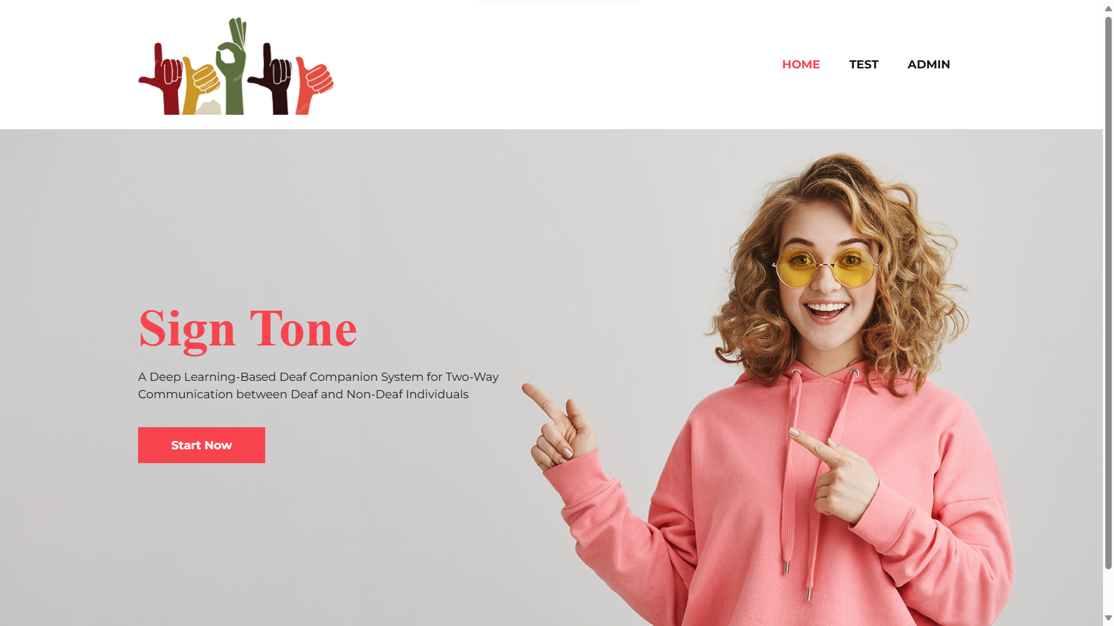

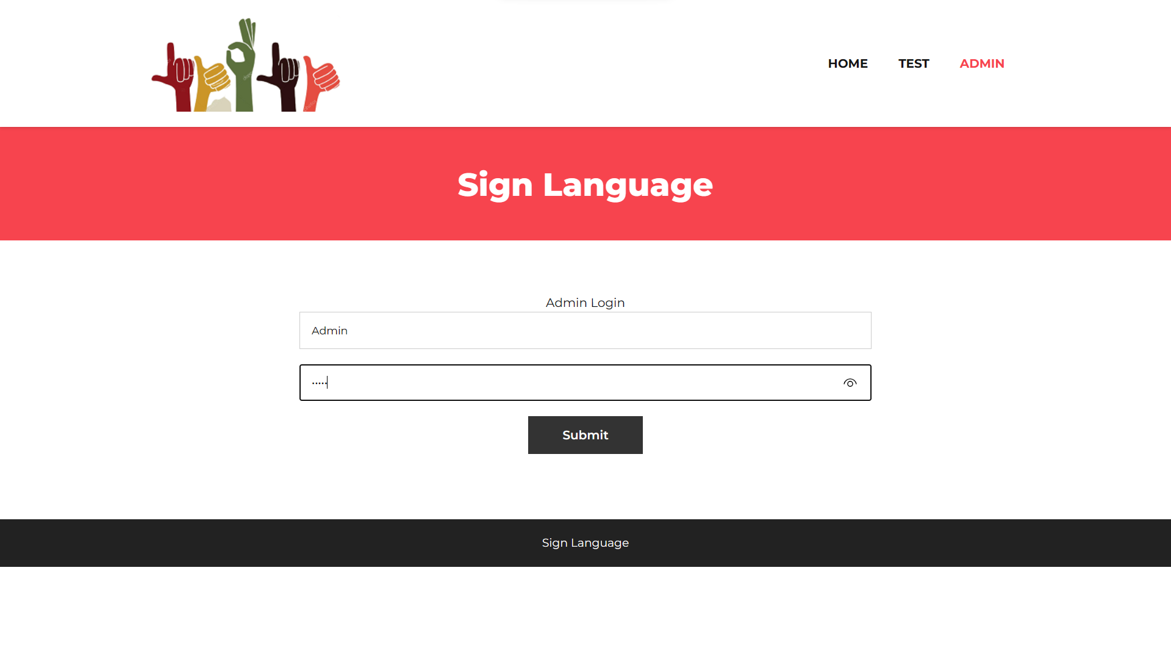

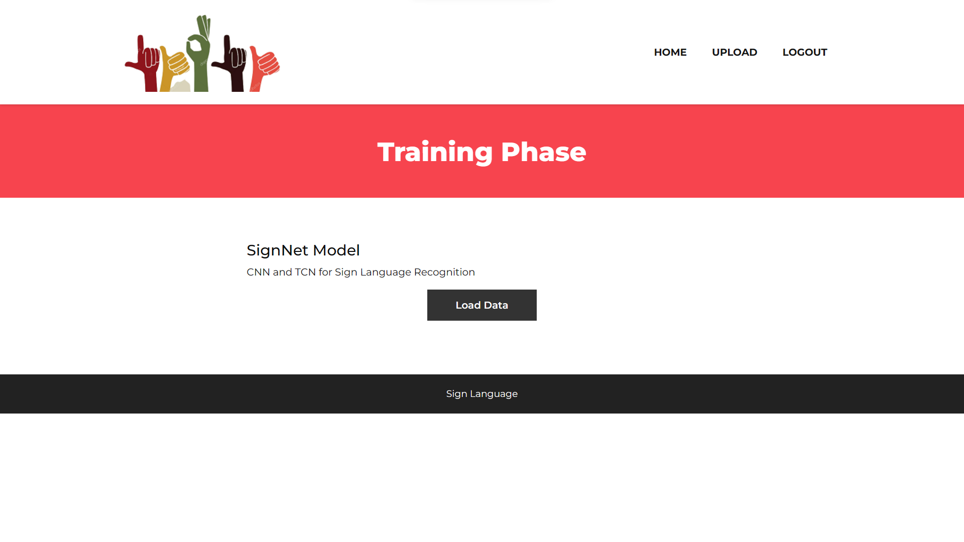

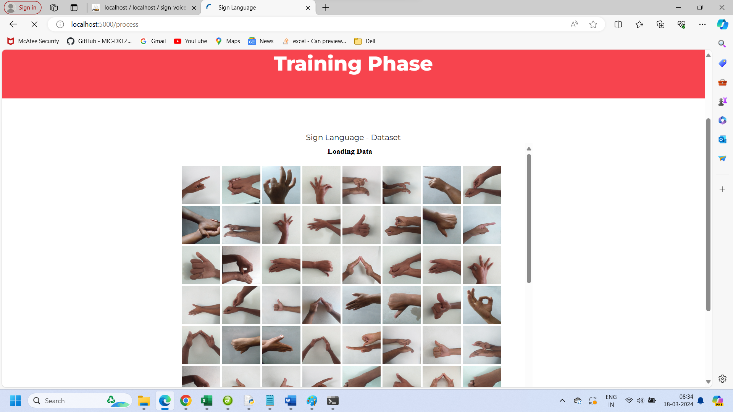

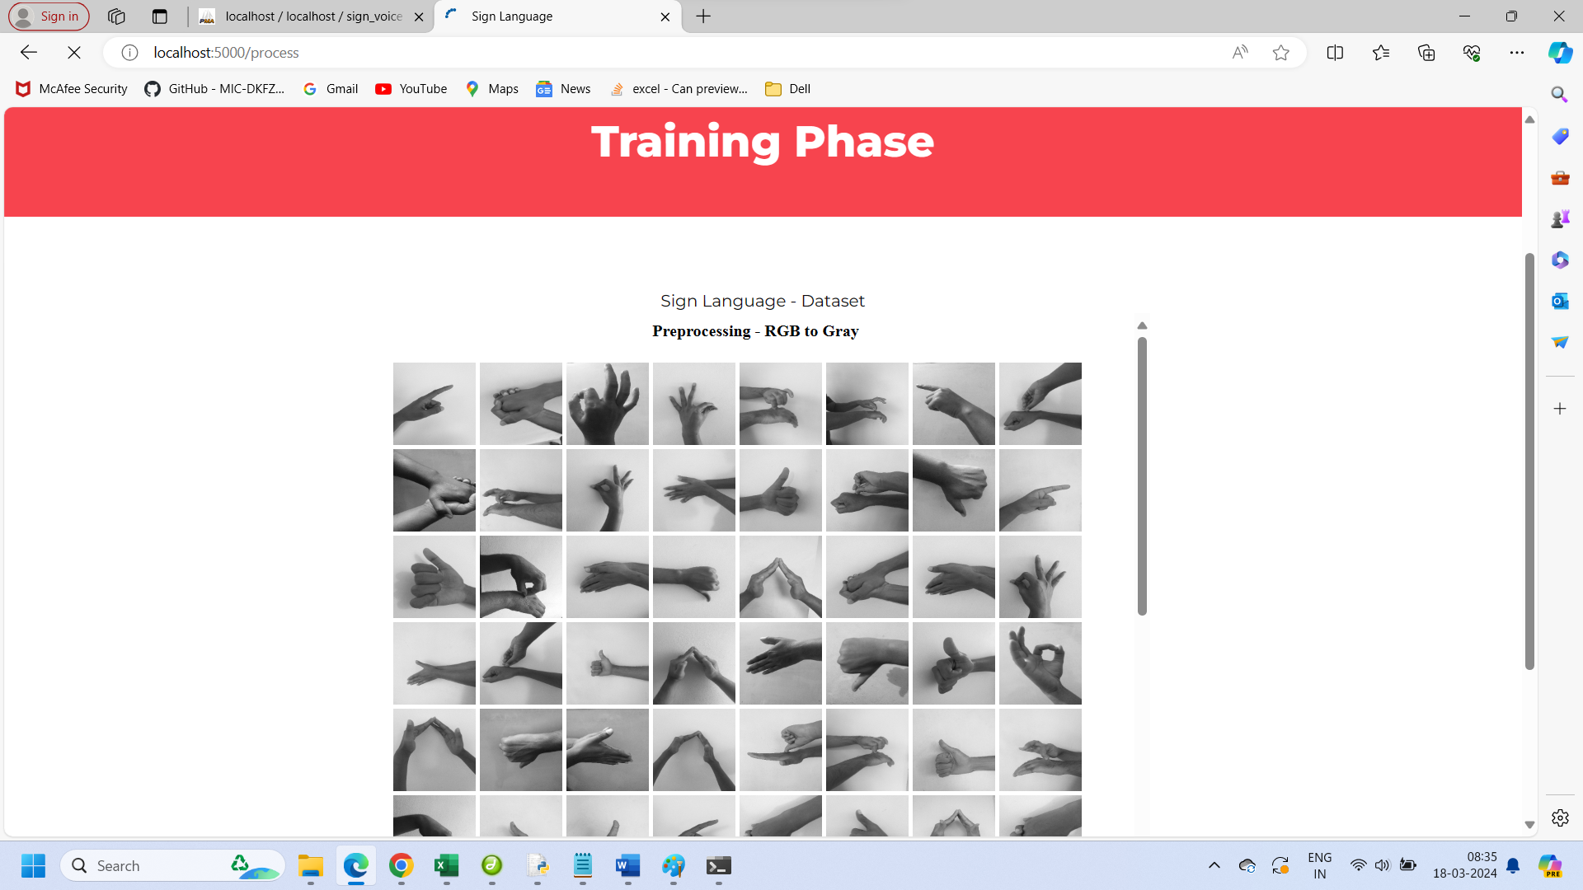

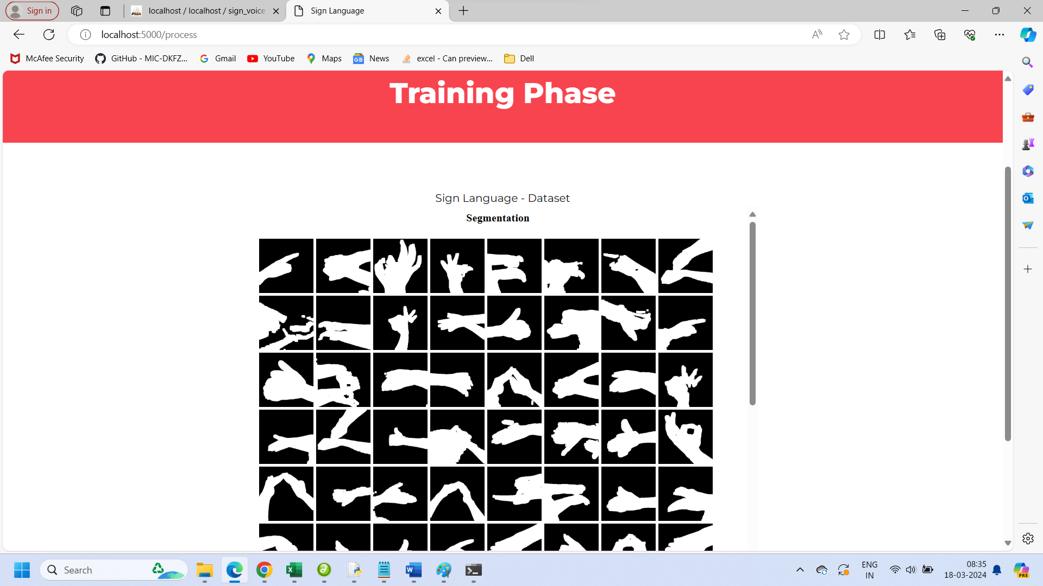

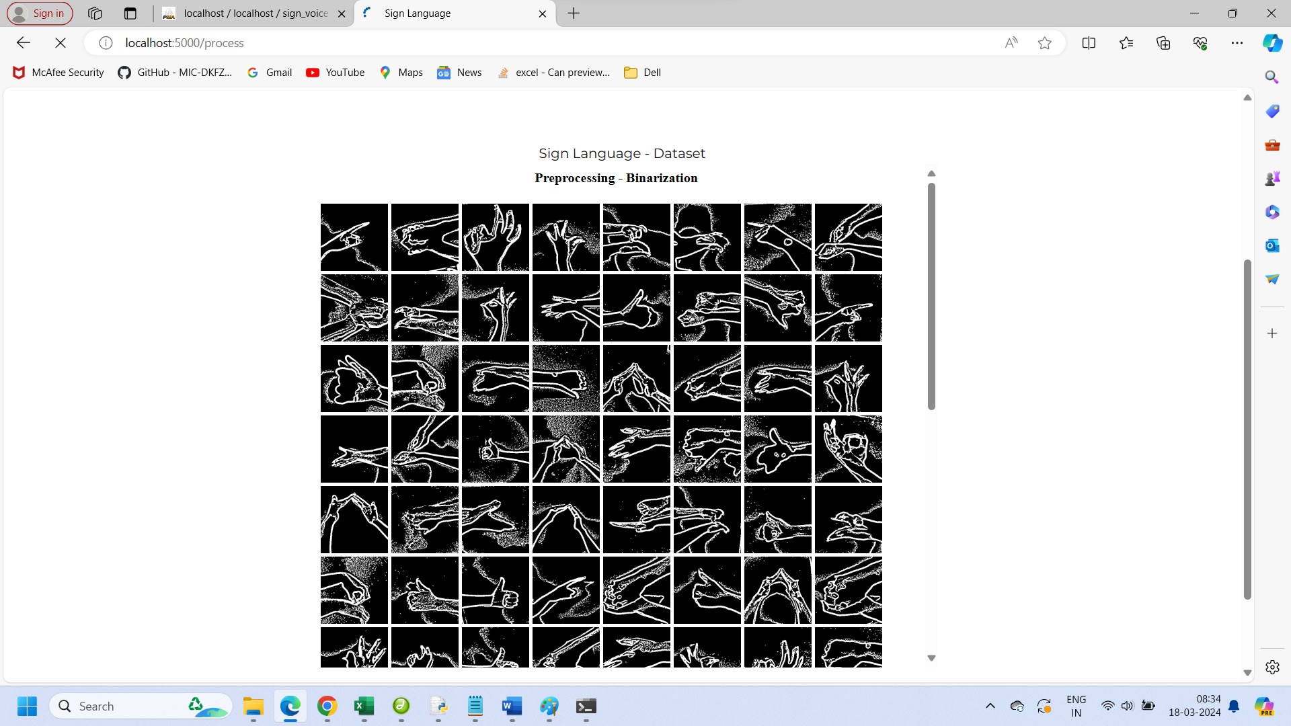

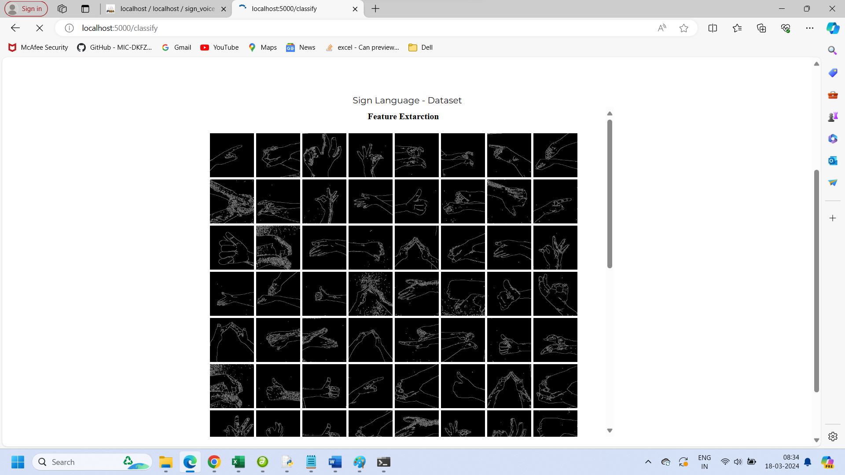

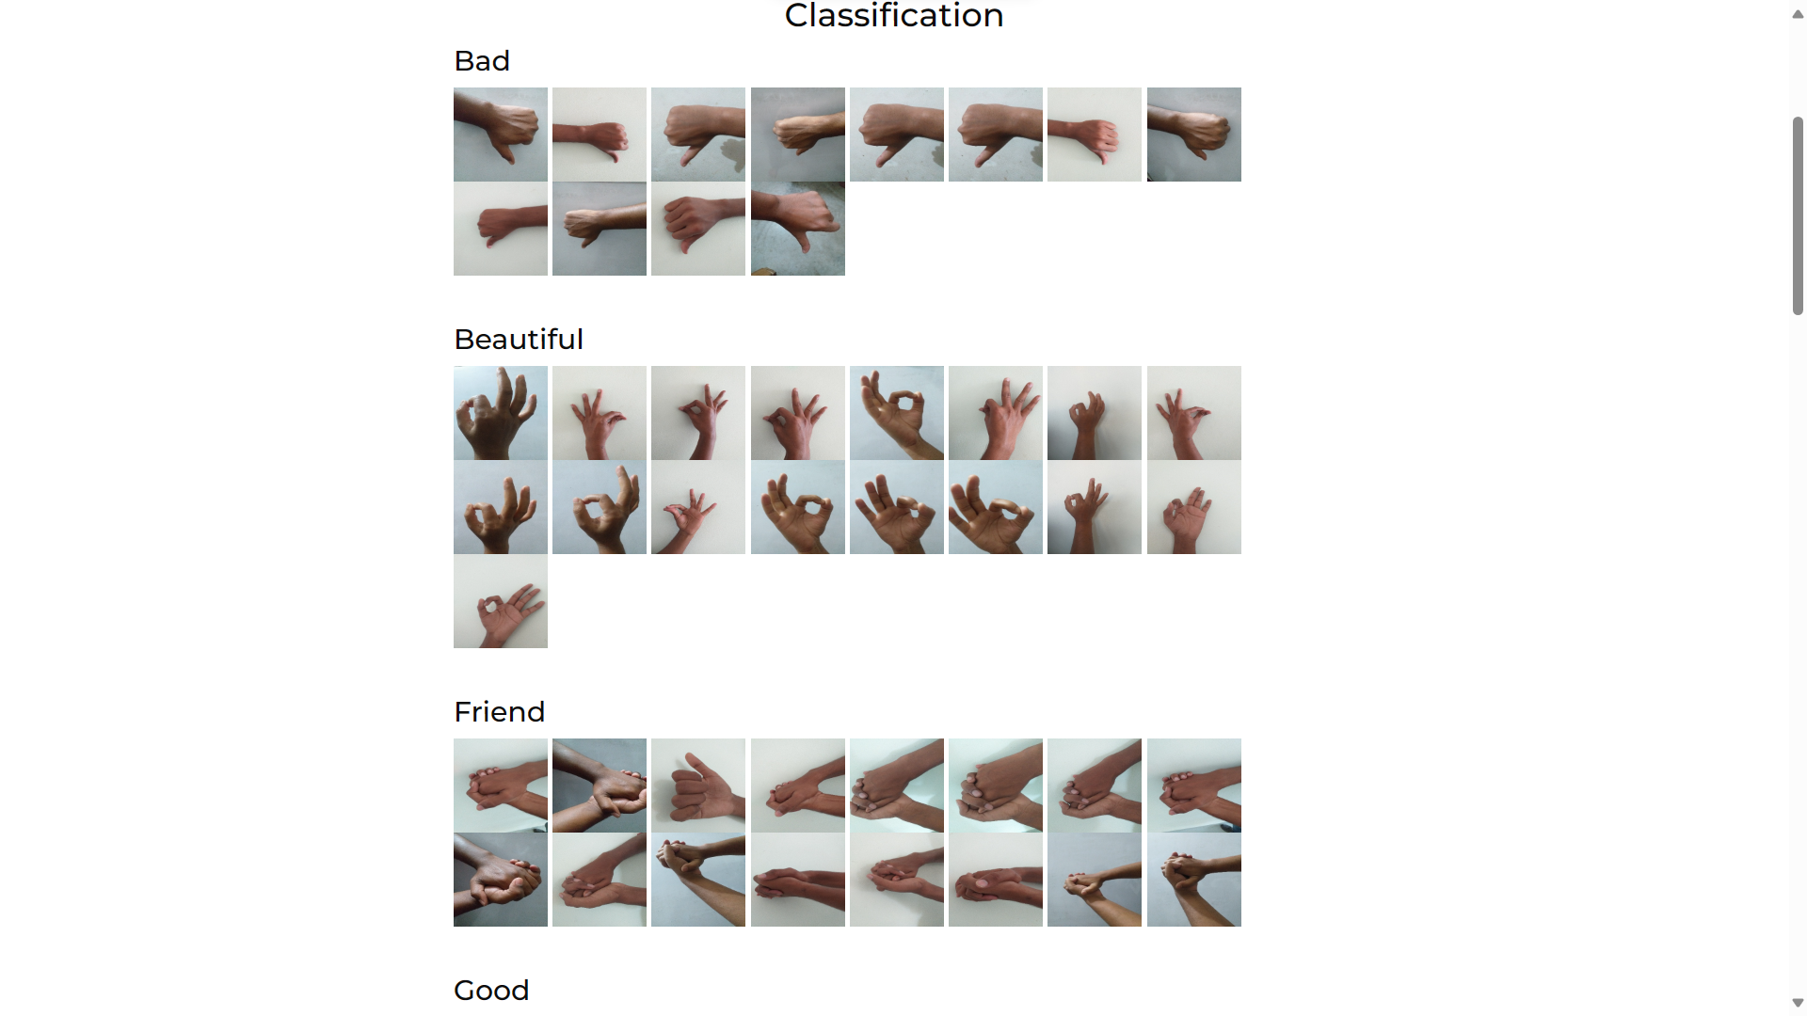

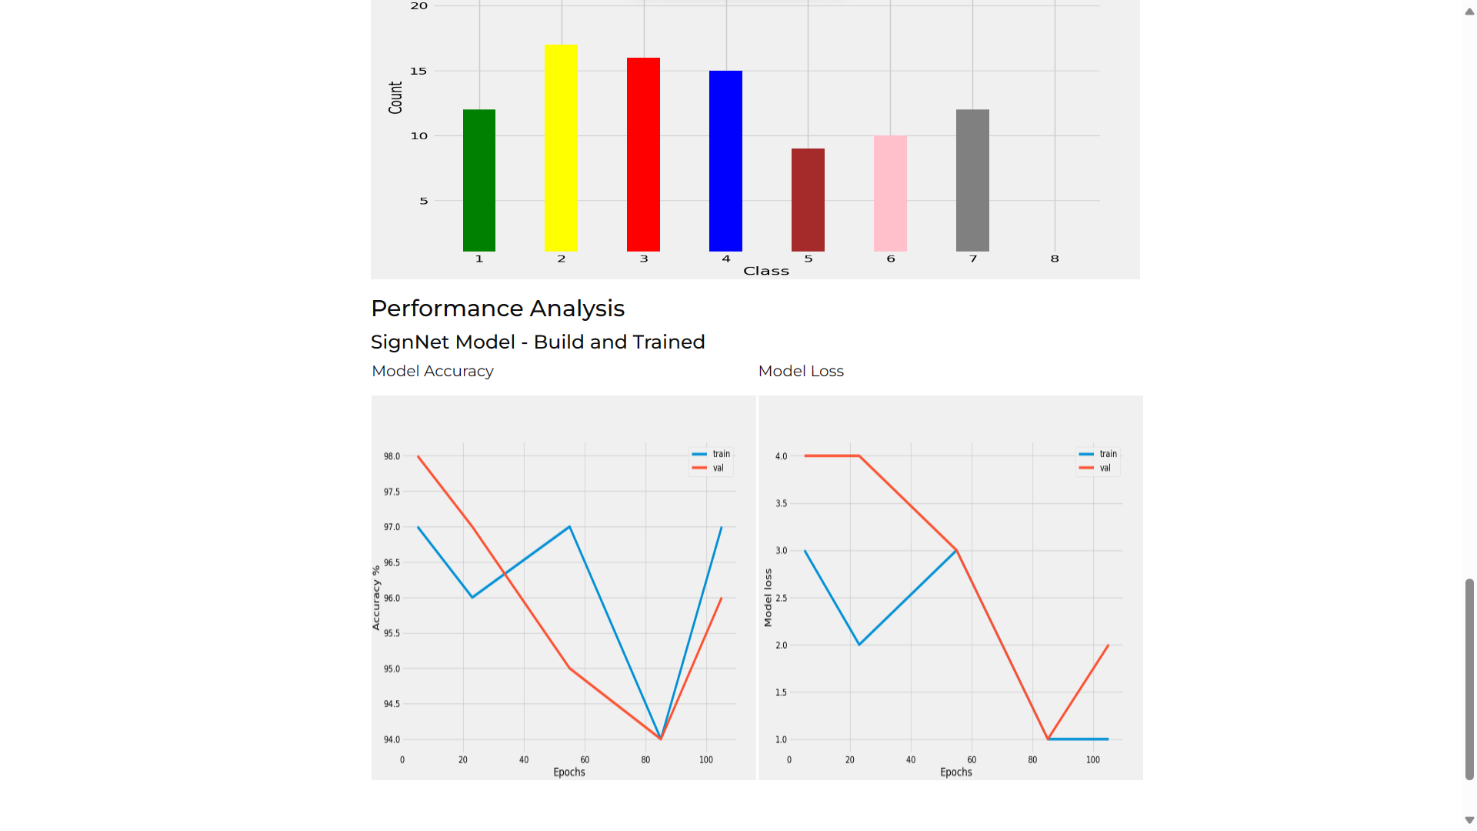

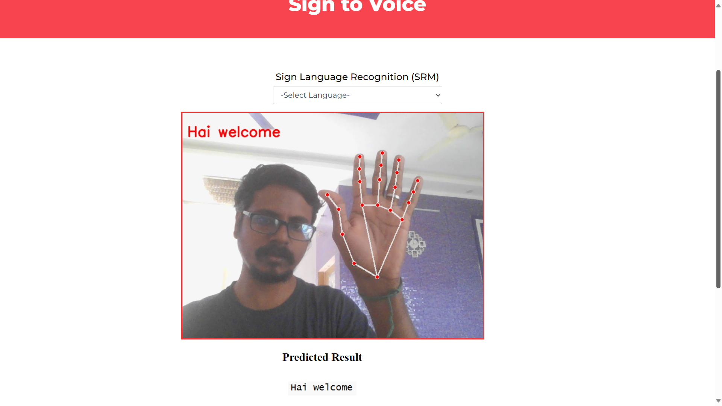

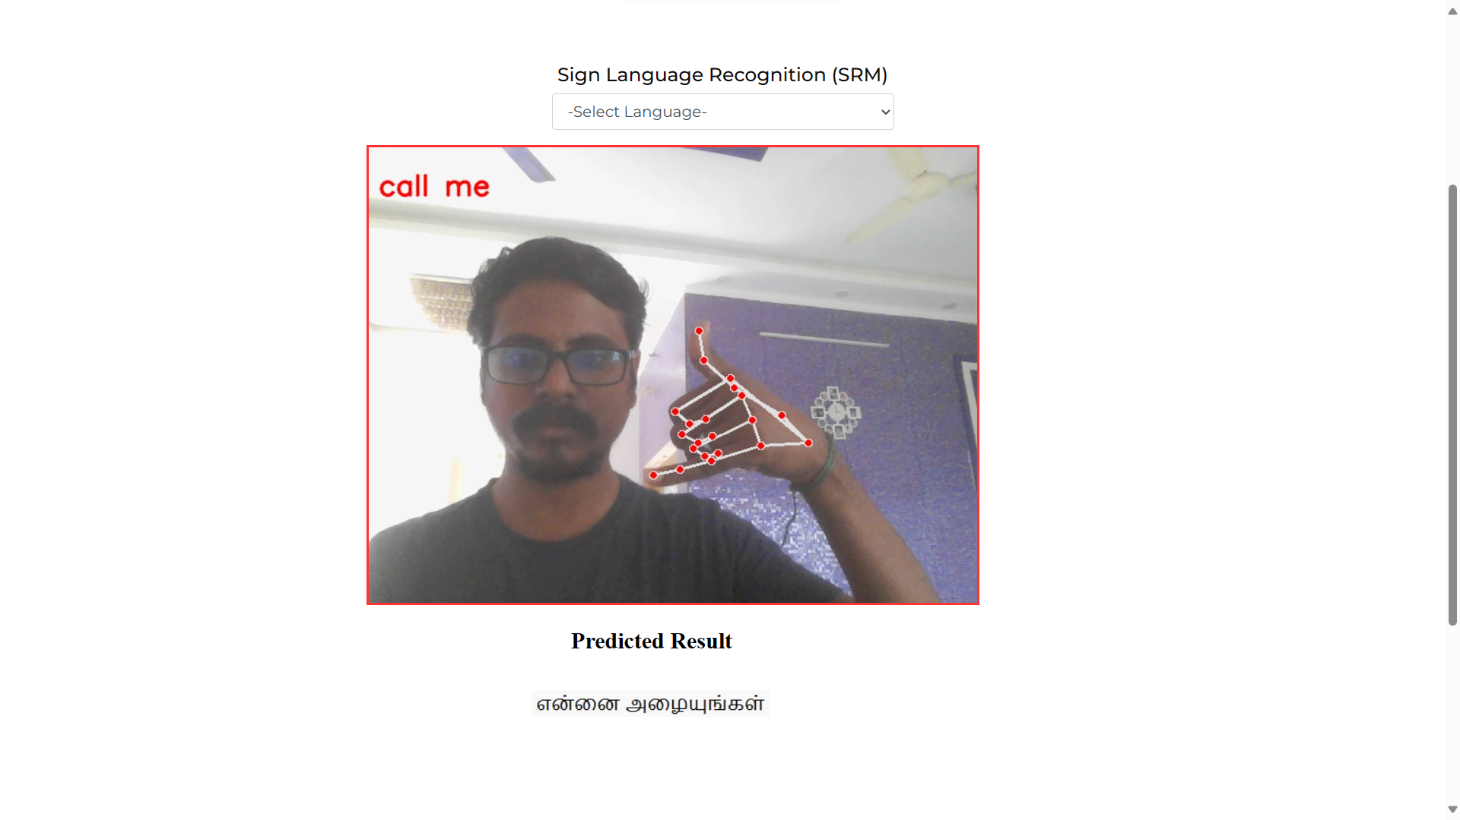

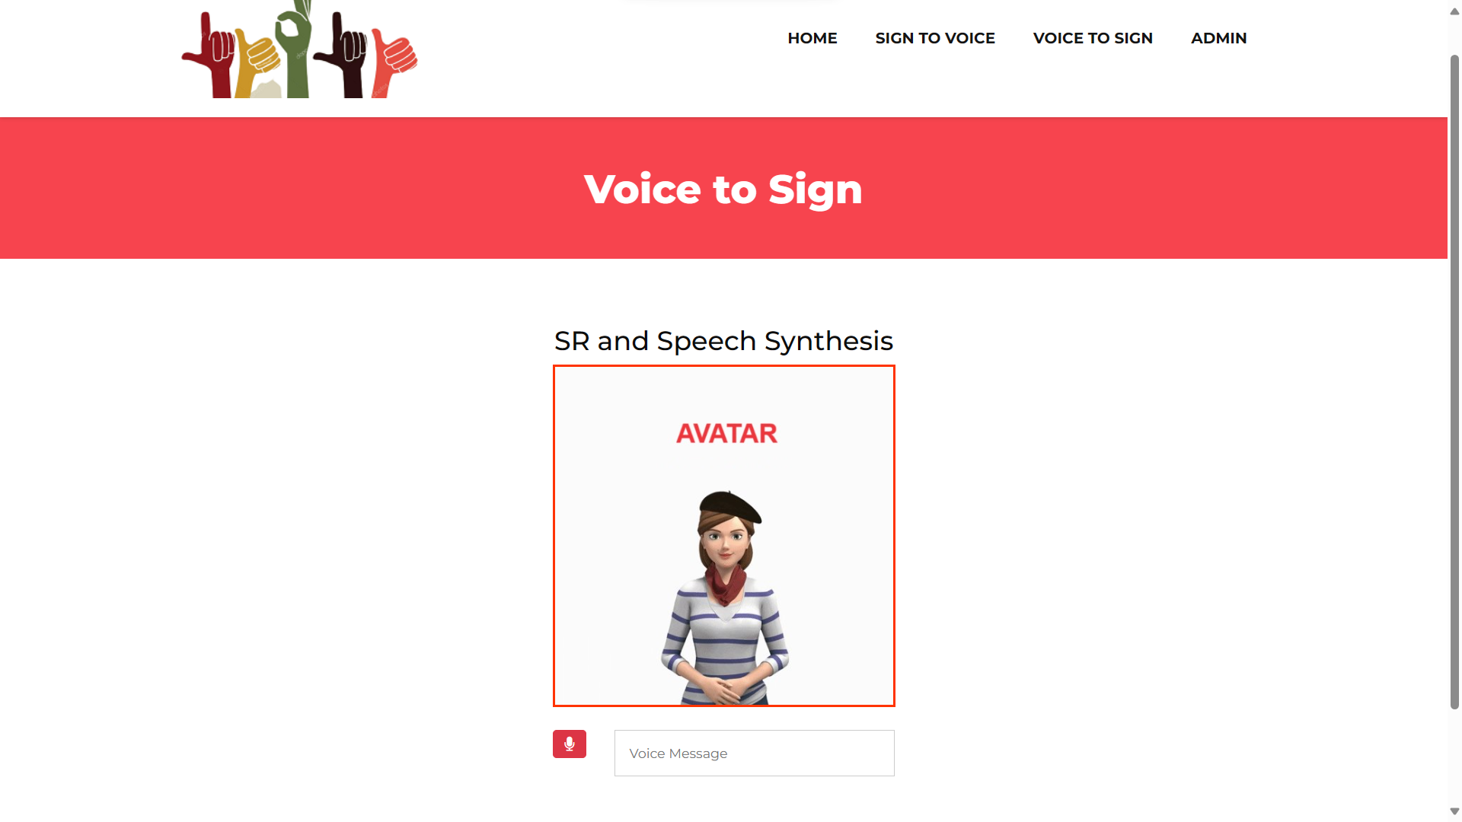

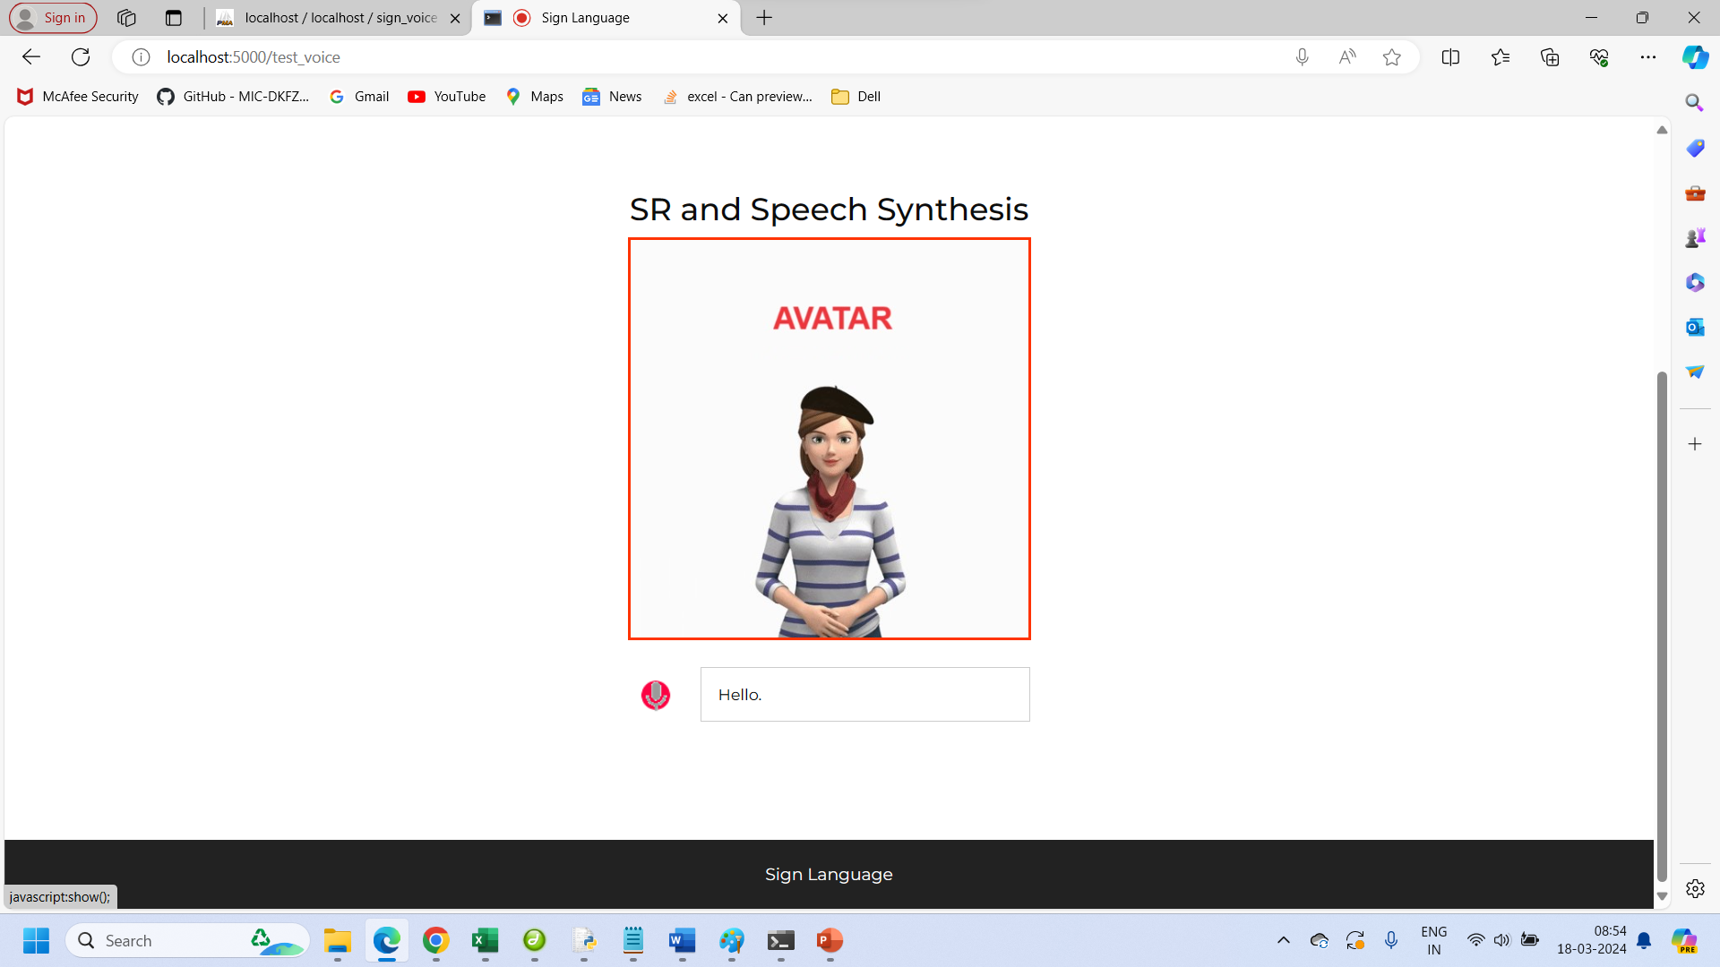

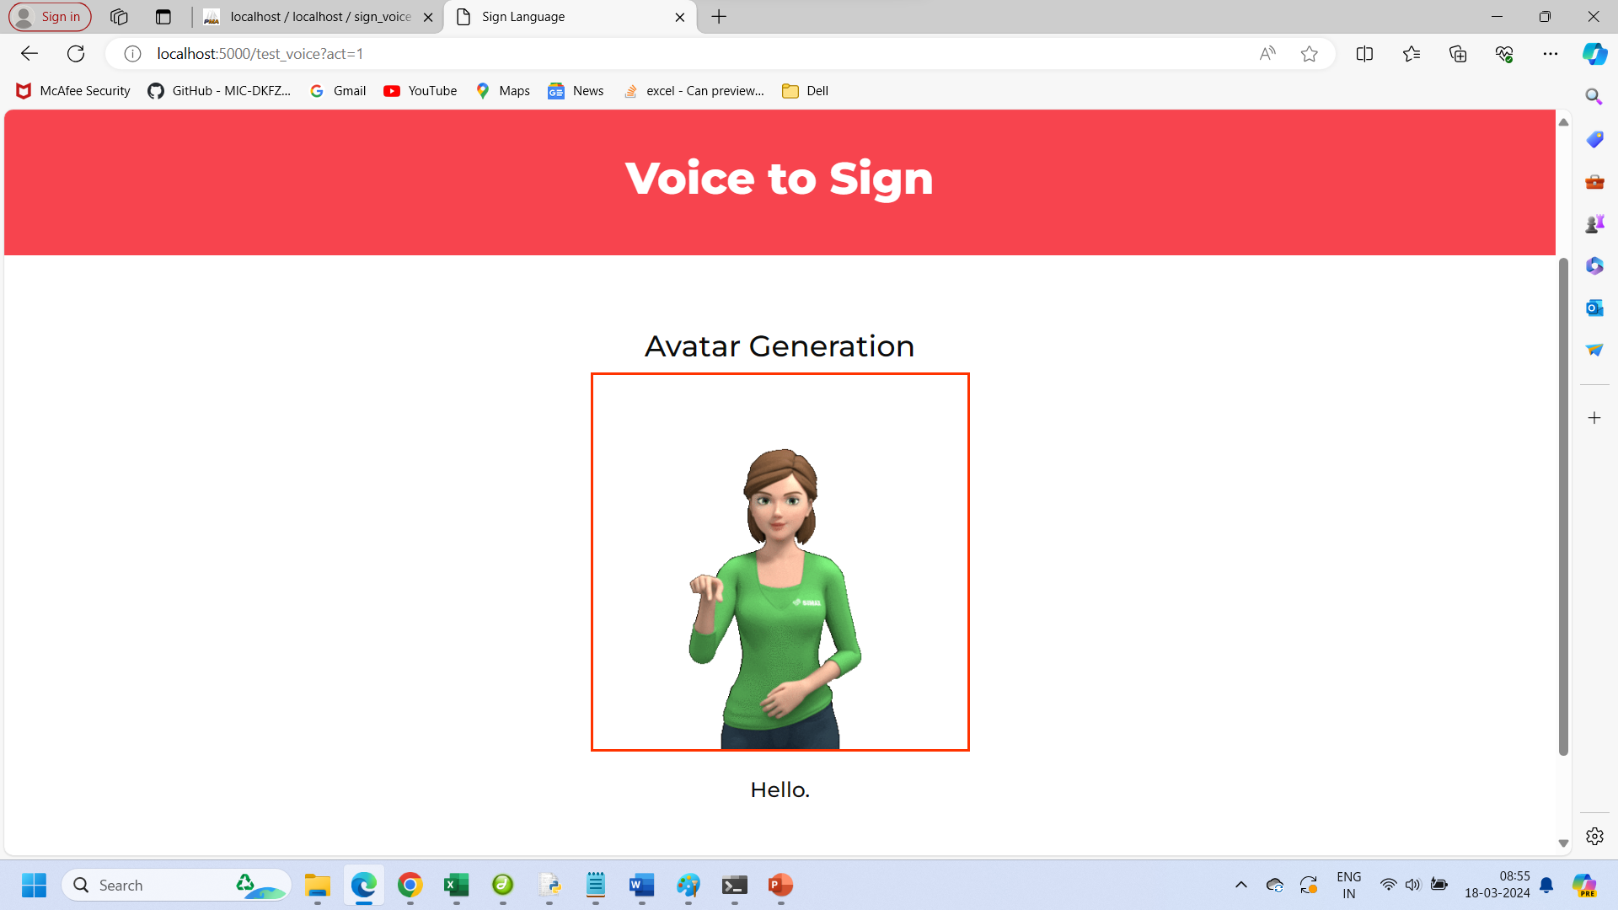

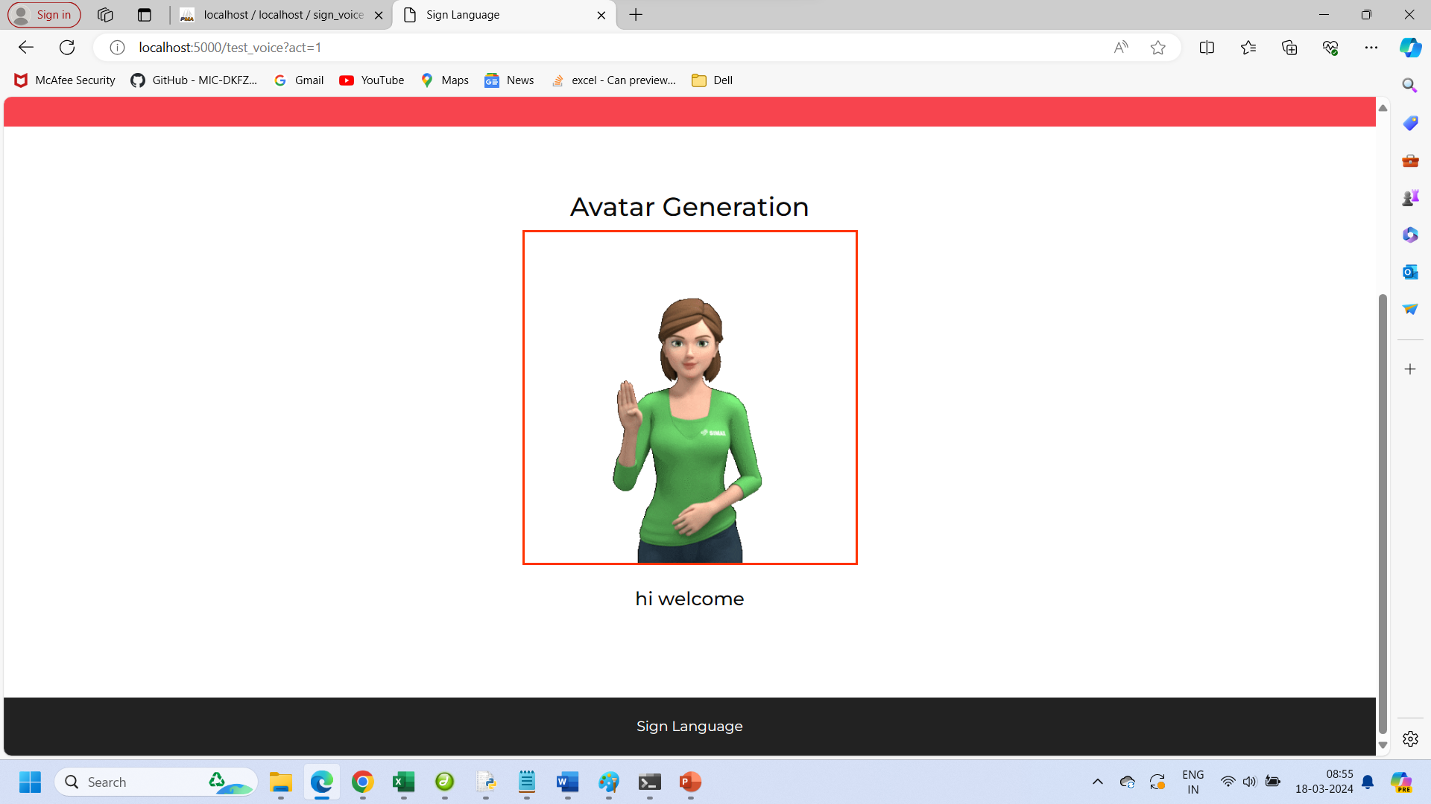

**8.CONCLUSION**

**8.1. CONCLUSION**

In conclusion, the Deaf Companion System represents a significant milestone in the realm of assistive technology, providing a comprehensive solution to facilitate communication for individuals with hearing and mute disabilities. Through the integration of advanced technologies such as Temporal Convolutional Networks (TCNs), Hidden Markov Models (HMMs), and Convolutional Neural Networks (CNNs), the system enables real-time interpretation of sign language gestures and conversion of spoken language into text, fostering seamless communication between deaf and non-deaf individuals. The project's success lies in its robust performance, user-centric design, and adaptability to diverse linguistic preferences. By offering multilingual interpretation and customizable avatar generation, the system caters to the diverse needs of its users, promoting inclusivity and accessibility in communication. Looking ahead, the project opens avenues for further research and development in the field of assistive technology. Future enhancements could focus on expanding language support, improving accuracy and efficiency, and integrating additional features to enhance user experience. Overall, the Deaf Companion System stands as a testament to the transformative potential of technology in empowering individuals with disabilities, bridging communication barriers, and fostering a more inclusive society.

**8.2. FUTURE ENHANCEMENT**

Integration with smart assistive devices such as smart glasses and wearable sensors presents opportunities to enhance accessibility and functionality, providing context-aware assistance for users. Developing a mobile application version will extend accessibility, ensuring compatibility across platforms and seamless integration with smartphone features. Expanding language support to include various sign languages and spoken languages through machine translation will further promote inclusivity and cross-cultural communication within the system.

**9.BIBLIOGRAPHY**

**9.1. JOURNAL REFERENCE**

1. T. Reddy Gadekallu, G. Srivastava, and M. Liyanage, “Hand gesture recognition based on a Harris hawks optimized convolution neural network,” Computers & Electrical Engineering, vol. 100, Article ID 107836, 2022.
2. G. T. R. Chiranji Lal Chowdhary and B. D. Parameshachari, Computer Vision and Recognition Systems: Research Innovations and Trends, CRC Press, 2022.
3. M.M. Riaz and Z. Zhang, "Surface EMG Real-Time Chinese Language Recognition Using Artificial Neural Networks" in Intelligent Life System Modelling Image Processing and Analysis Communications in Computer and Information Science, Springer, vol. 1467, 2021.
4. G. Halvardsson, J. Peterson, C. Soto-Valero and B. Baudry, "Interpretation of Swedish sign language using convolutional neural networks and transfer learning", SN Computer Science, vol. 2, no. 3, pp. 1-15, 2021.
5. P. Likhar, N. K. Bhagat and R. G N, "Deep Learning Methods for Indian Sign Language Recognition", 2020 IEEE 10th International Conference on Consumer Electronics (ICCE-Berlin), pp. 1-6, 2020.
6. F. Li, K. Shirahama, M. A. Nisar, X. Huang and M. Grzegorzek, "Deep Transfer Learning for Time Series Data Based on Sensor Modality Classification", Sensors, vol. 31, no. 20(15), pp. 4271, Jul 2020.
7. J. J. Bird, A. Ekárt and D. R. Faria, "British sign language recognition via late fusion of computer vision and leap motion with transfer learning to american sign language", Sensors, vol. 20, no. 18, pp. 5151, 2020.
8. S. Sharma, R. Gupta and A. Kumar, "Trbaggboost: an ensemble-based transfer learning method applied to Indian Sign Language recognition", J Ambient Intell Human Comput Online First, 2020, [online] Available: https://doi.org/10.1007/s12652-020-01979-z.
9. M. Oudah, A. Al-Naji and J. Chahl, "Hand Gesture Recognition Based on Computer Vision: A Review of Techniques", *J. Imaging*, vol. 6, no. 73, 2020.
10. Z. M. Shakeel, S. So, P. Lingga and J. P. Jeong, "MAST: Myo Armband Sign-Language Translator for Human Hand Activity Classification", IEEE International Conference on Information and Communication Technology Convergence, pp. 494-499, 2020.
11. M. Zakariya and R. Jindal, "Arabic Sign Language Recognition System on Smartphone", 2019 10th International Conference on Computing Communication and Networking Technologies (ICCCNT), pp. 1-5, 2019.
12. E. Abraham, A. Nayak and A. Iqbal, "Real-Time Translation of Indian Sign Language using LSTM", 2019 Global Conference for Advancement in Technology (GCAT), pp. 1-5, 2019.
13. O. Koller, N. C. Camgoz, H. Ney and R. Bowden, "Weakly supervised learning with multi-stream CNN-LSTM-HMMs to discover sequential parallelism in sign language videos", IEEE Trans. Pattern Anal. Mach. Intell., vol. 42, no. 9, pp. 2306-20, 2019.
14. A. A. Hosain, P. S. Santhalingam, P. Pathak, J. Kosecka and H. Rangwala, "Sign language recognition analysis using multimodal data", 2019.
15. J. Huang, W. Zhou, Q. Zhang, H. Li and W. Li, "Video-based sign language recognition without temporal segmentation", AAAI, vol. 32, no. 1, pp. 2257-64, 2018.
16. D. Konstantinidis, K. Dimitropoulos and P. Daras, "Sign language recognition based on hand and body skeletal data", 3DTV-CON, pp. 1-4, 2018.
17. C. Motoche and M. E. Benalcázar, "Real-Time Hand Gesture Recognition Based on Electromyographic Signals and Artificial Neural Networks" in Artificial Neural Networks and Machine Learning - ICANN 2018 Lecture Notes in Computer Science, Springer, vol. 11139, 2018.
18. J. Pu, W. Zhou and H. Li, "Dilated convolutional network with iterative optimization for continuous sign language recognition", IJCAI, vol. 3, pp. 885-91, 2018.
19. R. Cui, H. Liu and C. Zhang, "Recurrent convolutional neural networks for continuous sign language recognition by staged optimization", *CVPR*, pp. 7361-9, 2017.
20. S. Y. Kim, H. G. Han, J. W. Kim, S. Lee, and T. W. Kim, “A hand gesture recognition sensor using reflected impulses,” IEEE Sensors Journal, vol. 17, no. 10, pp. 2975-2976, 2017.

**9.2. BOOK REFERENCES**

1. "Deep Learning" by Ian Goodfellow, Yoshua Bengio, and Aaron Courville.
2. "Hands-On Machine Learning with Scikit-Learn, Keras, and TensorFlow" by Aurélien Géron.
3. "Flask Web Development: Developing Web Applications with Python" by Miguel Grinberg.
4. "MySQL 8 Cookbook" by Karthik Appigatla.
5. "Computer Vision: Algorithms and Applications" by Richard Szeliski.
6. "Learning OpenCV 4 Computer Vision with Python 3" by Joseph Howse, Joe Minichino, and Coleman Platt.
7. "Sign Language Recognition: Offline and Online Implementation" by Ricardo Moya.
8. "Introduction to Deep Learning" by Eugene Charniak.
9. "Bootstrap 4 Quick Start: Responsive Web Design and Development Basics for Beginners" by Jacob Lett.

**9.3. WEB REFERENCES**

1. TensorFlow Documentation: <https://www.tensorflow.org/>
2. Flask Documentation: https://flask.palletsprojects.com/en/2.0.x/
3. MySQL Documentation: <https://dev.mysql.com/doc/>
4. OpenCV Documentation: <https://opencv.org/>
5. Bootstrap Documentation:

https://getbootstrap.com/docs/5.1/getting-started/introduction/

1. Scikit-learn Documentation: https://scikit-learn.org/stable/documentation.html
2. Pandas Documentation: https://pandas.pydata.org/docs/
3. NumPy Documentation: https://numpy.org/doc/
4. Matplotlib Documentation: https://matplotlib.org/stable/contents.html
5. Seaborn Documentation: https://seaborn.pydata.org/tutorial.html
6. WampServer Documentation: http://www.wampserver.com/en/documentation.php